Celebrating the Richness of God’s Grace

Proclaiming the Kingdom: beginning in Chisago County

+ Please stand if you are able

To enhance our worship, please turn off all cell phones and electronic devices.

Prelude and Silent Prayer

Welcome, Announcements and Greeting

Call to Worship

+Hymn #432 Jesu, Jesu

Children’s Message

+Hymn #549 vss 1,3,4,6 Where Charity and Love Prevail

Bible Reading John 13:31-35

Message Pastor Tom Ervasti

+Hymn #643 vss 1,2,3,4 When Love Is Found

Offering

+Offering Response #95 Praise God, from Whom All Blessings Flow

Prayers and Lord’s Prayer

+Hymn #560 Help Us Accept Each Other

+Benediction

+Dismissal
Leader: Go in peace to love and serve the Lord!
All: Thanks be to God!

+Postlude
Thank you for worshiping with us this morning!
This Week’s Calendar…

TODAY, Sunday, May 19
LAST Sunday School Classes
1:00p Adopt-a-Highway Clean-Up

Monday, May 20
4 – 6p Community Meal – Zion Lutheran Church, Chisago City
NO Bell Choir

Tuesday, May 21 Newsletter Deadline
7:00p Finance – lounge
8:00p Church Council - lounge

Wednesday, May 22
NO Choir
NO Worship Team

Thursday, May 23

Friday, May 24
Pastor’s Day Off

Saturday, May 25

Next Sunday, May 26
9:00a Worship / Andy Wilkerson, speaking
10:15a Fellowship

Monday, May 27 Memorial Day
Office Closed

Last week’s offering: $6,436 Budgeted Weekly: $3,693
Monthly giving (May): $12,328 Budgeted Monthly: $16,004

Attendance last Sunday: 88

Children at First
- ‘Worship Bags’ are in the foyer for children to borrow
- A Nursery for babies and toddlers is available every Sunday

Please Pray For: Cole Anderson; Sandy Danielson; Brad Elshaug;
Brian Elshaug; Rusty Johnson; George Hultman; Olga Determan;
Steve Graves; Lois Anderson; Greg Oien; Delores Stockel
Here’s What’s Happening…

Fellowship: Join us for coffee & treats in the fellowship hall following the service.

Our Mission Focus this month: MN Annual Conference Love Offering.
Recipient of 60 percent
The United Methodist Church’s presence in Laos is growing through the Lao Samphan Methodist Church (“Samphan” means “united”).

Recipient of 20 percent
Established in 1966, Volunteer Lawyers Network helps thousands of people each year by providing civil legal services to people living in poverty.

Recipient of 20 percent
Mission trips change the lives of participants by giving them an opportunity to grow in faith and gain a new perspective of the world.

Mission Envelopes: Mission Envelopes can be found in each pew rack. You are welcome to give to our monthly Mission Offering throughout the month using the designated envelope. Please make your check out to FUMC, marking “Missions” in the memo.

Sermon videos online: Did you miss a Sunday worship service? Sermon videos are on our website, www.lindstrommethodist.org. You will be able to listen to the sermon or view the video. Be sure to check out the rest of the website for more information.

Upper Room Devotional: The May/June issue of the Upper Room Devotional can be found on the table in the foyer.

Rev. John C. Blackford Scholarship Applications: Funded by the First UMC Foundation. All are eligible if a member or regular worshiper at First UMC, a relative of a church attendee, or a youth regularly involved in activities associated with the church. Applications can be obtained through the church office (651-257-4306), on the information table in the foyer, or electronically on our website. Applications will be evaluated by the Foundation members and awarded on need and merit. A detailed, thoughtful application will influence the final evaluation and selection. Please be as specific as possible. The most recent school transcript must be submitted with your application. Deadline for applications is June 6. Scholarships will be awarded June 30.

Memorial Wish List: The Memorial Committee is creating a Wish List of projects and things to be done around the church for the benefit of the church. If you have something to submit, please send an email to office@lindstrommethodist.org. Please provide a brief description of the project. Questions? See Greg Oien, Sharlene Arnold, or Linda Ploog.

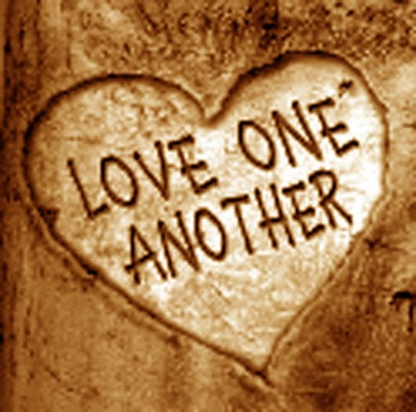

First United Methodist Church
30828 Irene Avenue P.O. Box 688
Lindstrom, Minnesota 55045

Phone: 651.257.4306
Email: office@lindstrommethodist.org
www.lindstrommethodist.org

May 19, 2019
9:00 a.m.

