Celebrating the Richness of God’s Grace

Proclaiming the Kingdom: beginning in Chisago County

+ Please stand if you are able

To enhance our worship, please turn off all cell phones and electronic devices.

Prelude and Silent Prayer

Welcome, Announcements and Greeting

Call to Worship

Worship with Song (please stand or sit as you wish)

Children’s Message

+Hymn #549 Where Charity and Love Prevail

Bible Reading Luke 6:27-38

Message Pastor Dale

+Hymn #572 Pass it On

Offering Just a Little Talk With Jesus Choir

+Offering Response #657 This Is the Day

Prayers and Lord’s Prayer

+Hymn #89 Joyful, Joyful, We Adore Thee

+Benediction

+Dismissal
Leader: Go in peace to love and serve the Lord!
All: Thanks be to God!

+Postlude

Thank you for worshiping with us this morning!
This Week’s Calendar…

Monday, February 25
4-6p Community Dinner at Zion Lutheran Church, Chisago City
NO Bell Choir

Tuesday, February 26
9:15a Women’s Bible Study – lounge

Wednesday, February 27
5:00p Family Dinner
5:30p Youth Bells
6:00p “The Life You’ve Always Wanted” Bible Study
6:00p Children/Youth Time – youth room
7:00p Choir
7:00p Confirmation
8:00p Worship Team

Thursday, February 28

Friday, March 1
Pastor’s Day Off
5:30p Club Rock

Saturday, March 2 World Day of Prayer

Next Sunday, March 3
9:00a Worship
10:15a Fellowship
Family Fun Day

Last week’s offering: $1,628 Budgeted Weekly: $3,701
Monthly giving (Feb.): $8,234 Budgeted Monthly: $16,040

Attendance last Sunday: 88

Children at First
- ‘Worship Bags’ are in the foyer for children to borrow
- A Nursery for babies and toddlers is available every Sunday

Please Pray For: Cole Anderson; Sandy Danielson; Brad Elshaug;
Brian Elshaug; Rusty Johnson; George Hultman; Olga Determan;
Steve Graves; Rebecca Ervasti; Baby Brooklyn & family; Laura & Phil

Here’s What’s Happening…

Fellowship: Join us for coffee & treats in the fellowship hall following the service.

Our Mission Focus this month: Red Bird Mission, Inc. and Red Bird Clinic, Inc. have been providing ministries in this region of Kentucky in the Appalachian Mountains since 1921. Today the need remains critical in this isolated, rural distressed area. You can help!

Mission Envelopes: Mission Envelopes can be found in each pew rack. You are welcome to give to our monthly Mission Offering throughout the month using the designated envelope. Please make your check out to FUMC, marking “Missions” in the memo.

Online Bill Pay…do you use your computer to pay your bills on-line? If you do, you may want to send your church offering/pledge through the same on-line bill pay service. You can set up an automatic payment plan or a one time contribution. It’s easy:
* First, login to your bill pay account
* Select Add a Bill
* Select Create an account without an account number
(use the address and phone number below)
First United Methodist Church
P.O. Box 688
Lindstrom, MN 55045
651-257-4306

Please see Greg Oien or Scott Lecy if you have any questions.

Unless your check or envelope designates an account, we assume it is for the General Fund. For bank-issued checks, if your contribution is for something other than General Fund, please enter in the "memo" line the account you wish your gift be recorded.

Women’s Tuesday Bible Study: Women’s Lenten Bible Study beginning March 5. We will be looking at The Final Words From the Cross, a study written by Adam Hamilton. Tuesdays 9:15 – 11:00 a.m. in the church lounge. Questions? Contact Cindy Kopp, 257-8526.

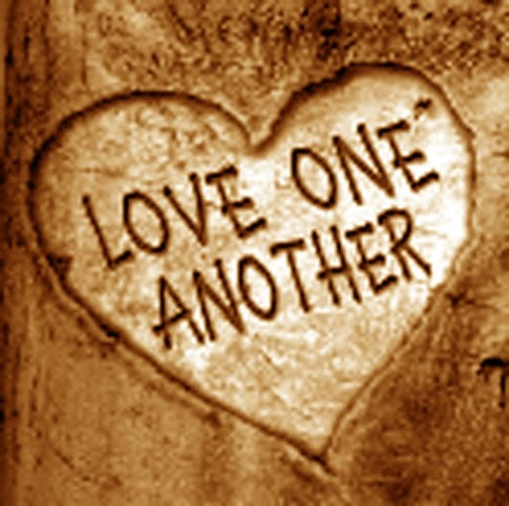

First United Methodist Church
30828 Irene Avenue P.O. Box 688
Lindstrom, Minnesota 55045

Phone: 651.257.4306
Email: office@lindstrommethodist.org
www.lindstrommethodist.org

February 24, 2019
9:00 a.m.

