Celebrating the Richness of God’s Grace

Proclaiming the Kingdom: beginning in Chisago County

+ Please stand if you are able

To enhance our worship, please turn off all cell phones and electronic devices.

Prelude and Silent Prayer

Welcome, Announcements and Greeting

Call to Worship

Worship with Song (please stand or sit as you wish)

Children’s Message

+Hymn #77 How Great Thou Art

Bible Reading 1 Corinthians 12:12-27

Message Pastor Dale

+Song (screen) We All Are One in Mission

Offering Many Gifts Choir

+Offering Response #95 Praise God, from Whom All Blessings Flow

Prayers and Lord’s Prayer

+Hymn (Green Book #3154) Draw the Circle Wide

+Benediction

+Dismissal
Leader: Go in peace to love and serve the Lord!
All: Thanks be to God!

+Postlude
Thank you for worshiping with us this morning!
This Week’s Calendar…

TODAY, September 23
Stay for picture following the church service for our anniversary!
6;30p Adult Study “Why I Believe in the God of the Bible” - lounge

Monday, September 24
4 – 6p Community Meal – Zion Lutheran Church, Chisago City
NO Bell Choir

Tuesday, September 25
9:15a Women’s Bible Study – lounge

Wednesday, September 26
5:00p Family Dinner
5:30p Youth Bells
6:00p “Living Your Strengths” Book Study
6:00p Children/Youth Time – youth room
7:00p Choir
7:00p Confirmation
8:00p Worship Team

Thursday, September 27

Friday, September 28
Pastor’s Day Off

Saturday, September 29

Next Sunday, September 30
9:00a Worship
10:15a Fellowship

“To-do” List: The Trustees have posted a “To-do” list in the fellowship hall of projects that need to be done around the building. Choose a project and cross off when completed. Please contact Lloyd Jones, 651-213-3110 if you need any materials to complete a project.

Last week’s offering: $2,992 Budgeted Weekly: $3,561
Monthly giving (Sept.): $5,130 Budgeted Monthly: $15,429

Attendance last Sunday: 104

Children at First
- ‘Worship Bags’ are in the foyer for children to borrow
- A Nursery for babies and toddlers is available every Sunday

Please Pray For: Cole Anderson; Doris Brand; Sandy Danielson
Here’s What’s Happening…

Fellowship: Join us for coffee & treats in the fellowship hall following the service.

Our Mission Focus this month: NOMADS – Nomads On Mission And Divine Service. Team members do maintenance, cleaning, painting, electrical, drywall, sewing, flooring. With God’s help, NOMADS pretty much do it all.

Mission Envelopes: Mission Envelopes can be found in each pew rack. You are welcome to give to our monthly Mission Offering throughout the month using the designated envelope. Please make your check out to FUMC, marking “Missions” in the memo.

Adult Small Group Study – TODAY, Sept.23, 6:30 p.m. “WHY I BELIEVE” by Chip Ingram will be the bi-weekly series that we will discuss in a Small Group setting. For more information talk to Scott Lecy.

Contribution Envelopes for 2019: We are getting ready to order contribution envelopes for 2019. If you are not currently utilizing envelopes for your weekly or monthly financial gifts to the church and would like to, please put a note in the offering tray or let the church office know. The use of envelopes assist the counters and entering contribution information into our computer system. Any questions, please contact Linda Ploog. Deadline is TODAY.

Women’s Bible Study: We will begin the year with a study on some of Jesus' parables. We meet on Tuesday mornings 9:15 - 11:00 and all women are welcome. Contact Cindy Kopp - 257-8526

Cradle Rocking #96: Sunday, Oct. 14, 9:00 a.m. This event is based on a Swedish custom of rocking babies one year and under in a cradle while children sing songs over them. If you or anyone you know would like to have their baby rocked, please contact Sandy Gaudette, 651-213-3127.

Operation Christmas Child Shoeboxes: It’s Operation Christmas Child time again! The youth will be collecting items for shoeboxes. You’ll find all the details of what to donate on the table in the hallway, or visit www.samaritanspurse.org/operation-christmas-child/pack-a-shoe-box. There will be a box in the foyer for your items. Our Shoebox Packing Party will be on Wednesday, November 14th from 7-9pm in the Fellowship Hall. ALL are welcome!

50 Year Anniversary: The first Sunday morning worship service at the new First United Methodist Church took place on September 22, 1968. The congregation had moved from a small white church on, now, Hwy 8 to a large brick building at 3rd & Irene. This Sunday we would like to recognize and remember those who made the dream of a spacious modern church home possible. Thank you to all those who attended here fifty years ago and are still faithful members--(Picture will be taken at the end of the service. Please stay for it)

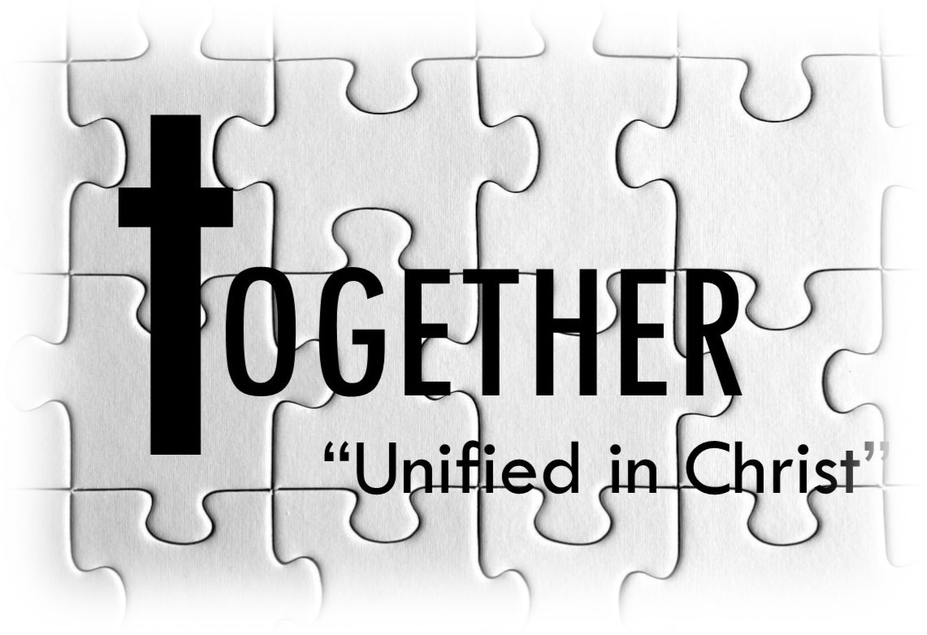

First United Methodist Church
30828 Irene Avenue P.O. Box 688
Lindstrom, Minnesota 55045

Phone: 651.257.4306
Email: office@lindstrommethodist.org
www.lindstrommethodist.org

September 23, 2018
9:00 a.m.

