Celebrating the Richness of God’s Grace

Proclaiming the Kingdom: beginning in Chisago County

+ Please stand if you are able

To enhance our worship, please turn off all cell phones and electronic devices.

Prelude and Silent Prayer

Welcome, Announcements and Greeting

Mission Moment Feed My Starving Children

Call to Worship

Worship with Song (please stand or sit as you wish)

Children’s Message

+Hymn #77 How Great Thou Art

Scripture Reading John 6:51-58

Message Pastor Dale

+Hymn #557 Blest Be the Tie That Binds

Offering There’s No Disappointment in Jesus Barbara Lunsford, piano

+Offering Response #89 (vss 1-2) Joyful, Joyful, We Adore Thee

Prayers and Lord’s Prayer

+Hymn #671 Lord, Dismiss Us with Thy Blessing

+Benediction

+Dismissal
Leader: Go in peace to love and serve the Lord!
All: Thanks be to God!

+Postlude
Thank you for worshiping with us this morning!
This Week’s Calendar…

TODAY, August 19
10:30a Children’s/Youth/Family Ministry Planning Meeting - lounge

Monday, August 20
4 – 6p Community Meal – Zion Lutheran Church, Chisago City

Tuesday, August 21 Newsletter Deadline
7:00p Trustees – lounge
8:00p Charge Conference followed by Church Council

Wednesday, August 22
1:45p Hope Circle at Panola Gardens

Thursday, August 23
7:00p Worship Team Rehearsal

Friday, August 24
Pastor’s Day Off

Saturday, August 25

Next Sunday, August 26
9:00a Worship
10:15a Fellowship

Last week’s offering: $1,910 Budgeted Weekly: $3,561
Monthly giving (August): $4,905 Budgeted Monthly: $15,429

Attendance last Sunday: 94

Children at First
- ‘Worship Bags’ are in the foyer for children to borrow

Blog: Did you know Pastor Dale writes and posts a BLOG on our website every Tuesday? Check it out!

Please Pray For: Cole Anderson; Doris Brand; Sandy Danielson

Here’s What’s Happening…

Fellowship: Join us for coffee & treats in the fellowship hall following the service.

Our Mission Focus this month: Feed My Starving Children. A Christian non-profit founded in 1987, Feed My Starving Children tackles world hunger by sending volunteer-packed, nutritious meals to 70 countries, where they are used to operate orphanages, schools, clinics and feeding programs to break the cycle of poverty.

Mission Envelopes: Mission Envelopes can be found in each pew rack. You are welcome to give to our monthly Mission Offering throughout the month using the designated envelope. Please make your check out to FUMC, marking “Missions” in the memo.

Adult Small Group Study – Study is postponed until Sunday, Sept. 9, 6:30 p.m. “WHY I BELIEVE” by Chip Ingram will be the bi-weekly series that we will discuss in a Small Group setting. For more information talk to Scott Lecy.

Hope Circle: A reminder for those who signed up for tea at Panola Valley Gardens, Wed., Aug. 22 @1:45 p.m.

Offering counters needed!: Two counters are required each Sunday. One counter takes the lead role while the other person assists. Commitment would be about 45 minutes one Sunday per month after the service. We will train!
If you are interested please contact Linda Ploog 651-257-3323.

Charge Conference: A Charge Conference has been scheduled for Tuesday, August 21, 8:00 p.m. (just before the Church Council meeting) with the purpose of approving the pastor’s salary for 2018. All members are encouraged to attend and vote.

Choir: Choir Rehearsal will begin Wednesday, Sept. 5, 7:00 p.m. in the sanctuary.

“Together: Created for Community”: On Rally Sunday, September 9, we will kick-off a four-week preaching and worship series entitled, “Together: Created for Community” that will end on Sunday, September 30. Weekly themes will explore how we, “Together”, are “Created for Community”, “Called by Jesus”, “Unified in Christ”, and “Sent Out to Serve.” Spread the word as we look forward to celebrating the community that exists at First UMC. Invite a friend to join you!

A Follow-Up Children, Youth & Family Ministry Planning Meeting will be held TODAY, in the fellowship hall immediately following worship. Anybody interested in being a part of these ministries as we plan for this fall is invited to attend. Talk to Pastor Dale if you’re interested but unable to attend.

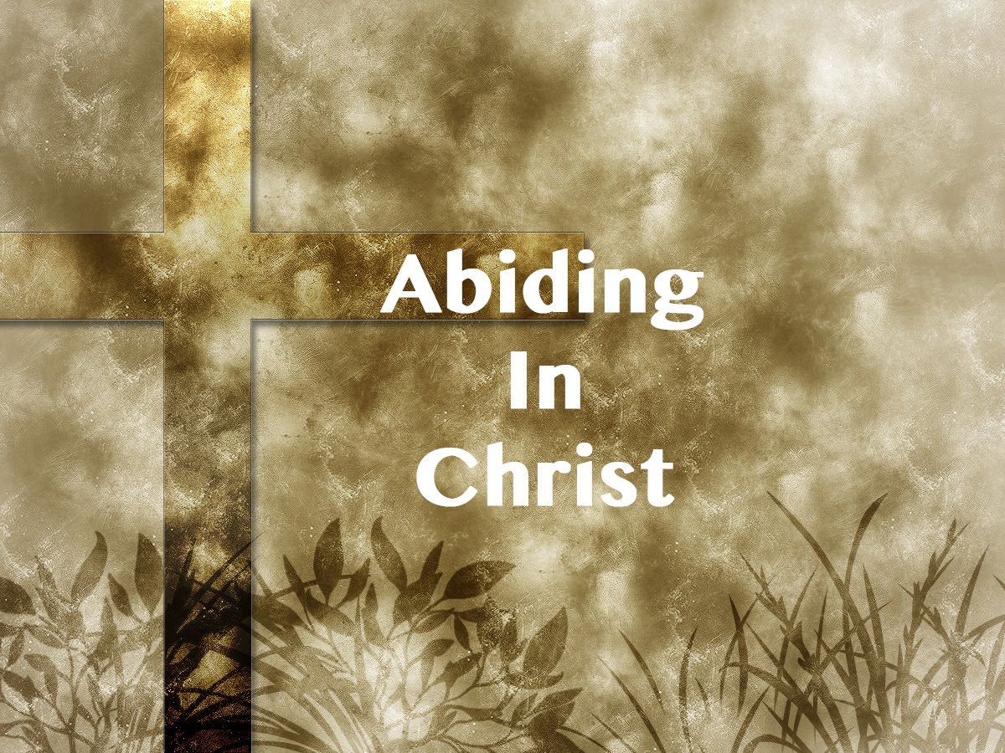

First United Methodist Church
30828 Irene Avenue P.O. Box 688
Lindstrom, Minnesota 55045

Phone: 651.257.4306
Email: office@lindstrommethodist.org
www.lindstrommethodist.org

August 19, 2018
9:00 a.m.

