Celebrating the Richness of God’s Grace

Proclaiming the Kingdom: beginning in Chisago County

+ Please stand if you are able

To enhance our worship, please turn off all cell phones and electronic devices.
Hearing devices are available at the sound booth.

Prelude

Words of Welcome/Attendance Registration

Announcements and Greeting

Praise and Worship (please stand or sit as you wish)

Children’s Moment
* Children 2 years- 8th grade are invited to go to Sunday School at this time
Grades 3rd -8th do not have Sunday school the first Sunday of the month

+Hymn #327 Crown Him with Many Crowns

Bible Reading Luke 24:13-35

Message Their Eyes Were Opened
Then their eyes were opened and they recognized him, and he disappeared from their sight. Luke 24:31

+Hymn #364 Because He Lives

Prayer

Service of Holy Communion Hymnal #12
Invitation
Confession and Pardon
The Great Thanksgiving
Words of Institution
Sharing the Bread and the Cup (gluten free available)
Offering (please bring your gifts as you come to commune)

+Hymn #303 The Day of Resurrection

+Benediction

+Postlude

Thank you for worshiping with us this morning!
This Week’s Calendar…

TODAY, April 8
10:15a Foundation Board
6:30p Adult Study - lounge

Monday, April 9
Pastor Dan out of the office
4-6p Community Dinner at Zion Lutheran Church, Chisago City
6:00p Bell Choir

Tuesday, April 10
9:15a Women’s Bible Study - lounge

Wednesday, April 11
5:00p Family Dinner
6:00p Adult Bible Study
7:00p Choir
8:00p Worship Team

Thursday, April 12
9:30a Hope Circle

Friday, April 13

Saturday, April 14

Next Sunday, April 15 Mission Sunday ~ Family Praise Fest
9:00a Worship / Sunday School
Message based on Acts 3:11-23
10:15a Fellowship
10:15a Memorial Committee - lounge

Last week’s offering: $14,104 Budgeted Weekly: $3,561
Monthly giving (April.): $14,104 Budgeted Monthly: $15,429

Attendance last Sunday: 162

Parking Lot Project Giving: $18,379 Needed: $32,500
If you would like to make a contribution, please make your check out to
First UMC, marking “Parking Lot” in the memo. The Finance Committee
has approved a dollar for dollar match.

Children at First
- ‘Worship Bags’ are in the foyer for children to borrow
- A Nursery for babies and toddlers is available every Sunday
Here’s What’s Happening…

Fellowship: Join us for coffee & treats in the fellowship hall following the service.

Our Mission Focus this month: Family Praise Fest.
Family Praise Fest started as an idea quite a few years ago and has grown into a great event and a community outreach program. Not only does it showcase our local Christian musical talent, it also brings the community together for an afternoon of fun, food, fellowship and praise. Plan on attending Sunday, April 15 to hear more about this year’s Family Praise Fest. Family Praise Fest will be held Sunday, June 24 at First UMC on the grounds north of the church building.

Mission Envelopes: Mission Envelopes can be found in each pew rack. You are welcome to give to our monthly Mission Offering throughout the month using the designated envelope. Please make your check out to FUMC, marking “Missions” in the memo.

Sermon videos online: Did you miss a Sunday worship service? Sermon videos are on our website. Go to www.lindstrommethodist.org and click on the Worship tab at the top of the page. Then click on the Sermon tab. You will be able to read the sermon or view the video. Be sure to check out the rest of the website for more information.

Looking for Summer Camp Sponsors: If you would like to impact the life of one of our kids at First UMC by being a camp sponsor, please contact Cheryl Lecy for options at 651-210-9839.

Community Meal: If you brought a pan of bars to the Monday Night Community Meal and have not picked up your pan following the meal, please do so soon at Zion Lutheran Church, Chisago City.

Adult Small Group Study – “WHY I BELIEVE” by Chip Ingram will be the bi-weekly series that we will discuss in a Small Group setting. Join us beginning TODAY, April 8, from 6:30-8:00 PM in the lounge. Conveniently, the week after Easter we will begin with “Why I Believe in the Resurrection.” For more information talk to Scott Lecy.

Please Pray For: Cole Anderson; Doris Brand

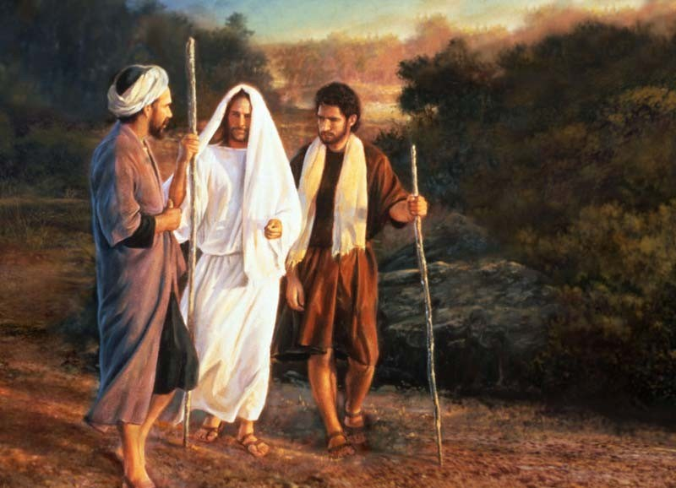

First United Methodist Church
30828 Irene Avenue P.O. Box 688
Lindstrom, Minnesota 55045
Phone: 651.257.4306
Email: firstmethodist@usfamily.net
www.lindstrommethodist.org

April 8, 2018
9:00 a.m.

