Celebrating the Richness of God’s Grace

Proclaiming the Kingdom: beginning in Chisago County

+ Please stand if you are able

To enhance our worship, please turn off all cell phones and electronic devices.
Hearing devices are available at the sound booth.

Prelude and Silent Prayer

+Hymn #278 Hosanna, Loud Hosanna

Words of Welcome/Attendance Registration

Announcements and Greeting

Call to Worship

Praise and Worship (please stand or sit as you wish)

Children’s Moment
* Children 2 years- 8th grade are invited to go to Sunday School at this time
Grades 3rd -8th do not have Sunday school the first Sunday of the month

+Hymn #3082 (Green Book) Who Is He

Bible Reading Mark 11:1-11

Choral Anthem Hosanna, Hosanna

Message Hosanna
Those who went ahead and those who followed shouted,
“Hosanna! Blessed is he who comes in the name of the Lord!” Mark 11:9

+Hymn #277 Tell Me the Stories of Jesus

Offering At the Cross Bell Choir

+Offering Response #176 Majesty, Worship His Majesty

Prayer

+Hymn #280 All Glory, Laud, and Honor

+Benediction

+Postlude

Thank you for worshiping with us this morning!
This Week’s Calendar…

Holy Week ~
Monday, March 26
4 – 6p Community Meal – Zion Lutheran Church, Chisago City
6:00p Bells

Tuesday, March 27
NO Women’s Bible Study

Wednesday, March 28
NO Family Dinner
NO Adult Bible Study
7:00p Choir
8:00p Worship Team

Thursday, March 29 Holy Thursday
7:00p Worship with Communion

Friday, March 30 Good Friday

Saturday, March 31 Holy Saturday

Next Sunday, April 1 EASTER!
7:30 – 8:45a Easter Breakfast served by the youth – free will offering
9:00a Worship / NO Sunday School
Message based on John 20:1-18

Last week’s offering: $1,676.26 Budgeted Weekly: $3,561
Monthly giving (March): $11,302.26 Budgeted Monthly: $15,429

Attendance last Sunday: 100

Parking Lot Project Giving: $2,134 Needed: $64,000
If you would like to make a contribution, please make your check out to
First UMC, marking “Parking Lot” in the memo.

Children at First
- ‘Worship Bags’ are in the foyer for children to borrow
- A Nursery for babies and toddlers is available every Sunday

Here’s What’s Happening…

Fellowship: Join us for coffee & treats in the fellowship hall following the service.

Our Mission Focus this month: UMCOR (United Methodist Committee On Relief)
Through UMCOR, United Methodists extend loving care to people within the United States, as well as those in Africa, Asia, Central and South America, and the Caribbean. These beneficiaries are seen as partners, not victims, and UMCOR works to empower them. Wherever possible, UMCOR cooperates with other aid organizations to extend its reach.

Mission Envelopes: Mission Envelopes can be found in each pew rack. You are welcome to give to our monthly Mission Offering throughout the month using the designated envelope. Please make your check out to FUMC, marking “Missions” in the memo.

Looking for Summer Camp Sponsors: If you would like to impact the life of one of our kids at First UMC by being a camp sponsor, please contact Cheryl Lecy for options at 651-210-9839.

Community Meal: If you brought a pan of bars to the Monday Night Community Meal and have not picked up your pan following the meal, please do so soon at Zion Lutheran Church, Chisago City.

Adult Small Group Study – “WHY I BELIEVE” by Chip Ingram will be the bi-weekly series that we will discuss in a Small Group setting. Join us beginning Sunday April 8, 2018 from 6:30-8:00 PM in the lounge. Conveniently, the week after Easter we will begin with “Why I Believe in the Resurrection.” For more information talk to Scott Lecy.

Holy Thursday: Join us Thursday, March 29, 7:00 p.m. for a worship service with Communion, remembering the Last Supper.

Please Pray For: Cole Anderson; Doris Brand; Olga Determan;
Jon Determan

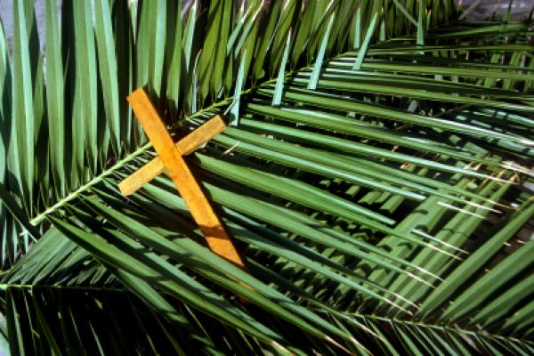

First United Methodist Church
30828 Irene Avenue P.O. Box 688
Lindstrom, Minnesota 55045
Phone: 651.257.4306
Email: firstmethodist@usfamily.net
www.lindstrommethodist.org

March 25, 2018
9:00 a.m.

