Celebrating the Richness of God’s Grace

Proclaiming the Kingdom: beginning in Chisago County

+ Please stand if you are able

To enhance our worship, please turn off all cell phones and electronic devices.
Hearing devices are available at the sound booth.

Prelude and Silent Prayer

Words of Welcome/Attendance Registration

Announcements and Greeting

Call to Worship

Hymn Sing

Children’s Moment

+Hymn #144 This Is My Father’s World

Bible Reading Luke 11:1-13

Message The Man’s Boldness
“I tell you, though he will not get up and give him the bread because he is his friend, yet because of the man’s boldness he will get up and give him as much as he needs.” Luke 11:8

Hymn #526 What a Friend We Have in Jesus

Offering

+Offering Response #95 Praise God…

Prayer

+Hymn #369 Blessed Assurance

+Benediction

+Postlude

Thank you for worshiping with us this morning!
This Week’s Calendar…

Monday, July 25

Tuesday, July 26
6:30p Men’s Softball – Ki-Chi-Saga Park - field 2
7:30p Men’s Softball – Ki-Chi-Saga Park - field 2

Wednesday, July 27

Thursday, July 28

Friday, July 29

Saturday, July 30

Next Sunday, July 31
9:00a Worship
Message based on Luke 12:13-34
10:15a Fellowship
10:30a Intercessory Prayer – chapel

Last week’s offering: $1,606 Budgeted Weekly: $3,618
Monthly giving (July): $8,947 Budgeted Monthly: $15,679

Attendance last Sunday: 82

Carpet Project Giving (Phase Two): $8,494 Goal: $23,500
Carpet Project: If you would like to make a contribution, please make your check out to First UMC, marking “carpet project” in the memo.

Children at First
- ‘Worship Bags’ are in the foyer for children to borrow
- A Nursery for babies and toddlers is available every Sunday

Please Pray For: Cole Anderson; Doris Brand; Roger Anderson; Steve & Susan Hernick; Jim McDermott; Nancy Paurus; David Heldt; Isaac Mitchell;
Britt, Kelvin & Baby

Here’s What’s Happening…

Fellowship: Join us for coffee and treats in the fellowship hall following the service.

Giving Statements: Mid-Year Giving Statements will not be available in the entryway this year. If you wish to receive a Mid-Year Statement, please talk with Patsy Berglund, 651-408-9642.

Our Mission Focus this month: Reach * Renew * Rejoice
The Minnesota Conference’s vision is for all congregations to live out God’s call to grow in love of God and neighbor, reach new people, and heal a broken world. The Minnesota Conference’s seven-year plan for congregational development has two components: starting new churches and growing existing churches by equipping them to increase vitality.

Mission Envelopes: Mission Envelopes can be found in each pew rack. You are welcome to give to our monthly Mission Offering throughout the month using the designated envelope. Please make your check out to FUMC, marking “Missions” in the memo.

Help Wanted!!: Three or four people to form a team to for preparing and running slides for Sunday worship services. The team will rotate weekly so the commitment would be only once a month. Flexible schedule. It's easy and it's fun! You will receive plenty of training and support. Please contact Wendy if you are interested. email: markwendyv1@gmail.com, cell: 651-587-2928.

East Central MN A Brush With Kindness has scheduled 2016 Mission Week for August 13 through 20:
Wow! A chance to do mission work close to home! Here is a list of Brush
With Kindness projects which cannot be completed without you. Please don't think others have already stepped up and signed up. If God is calling you to serve, here are opportunities.

Stephanie project: Forest Lake - replace damaged exterior patio doors and a
window
Pat & John project: Chisago City - replace damaged siding and paint house
Richard project: Lindstrom - replace lower rotted siding and paint house and
garage. Some landscaping
Bruce project: Wyoming - Stain his wheel chair ramps and decks

Please see the sign-up page on the bulletin board in the church hallway or call Boni Stockel at (612)-229-9396.

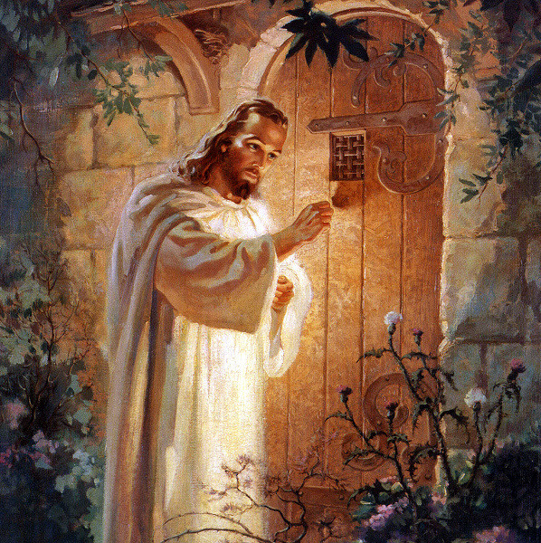

First United Methodist Church
30828 Irene Avenue P.O. Box 688
Lindstrom, Minnesota 55045
Phone: 651.257.4306
Email: firstmethodist@usfamily.net
www.lindstrommethodist.org

July 24, 2016
9:00 a.m.

