Celebrating the Richness of God’s Grace

Proclaiming the Kingdom: beginning in Chisago County

+ Please stand if you are able

To enhance our worship, please turn off all cell phones and electronic devices.
Hearing devices are available at the sound booth.

Prelude and Silent Prayer

Words of Welcome/Attendance Registration

Announcements and Greeting

Lighting of the Advent Candle Beth Lunsford and Nancy Grossmann

+Praise and Worship (please stand or sit as you wish)

Children’s Moment
* Children 3 years – 8th grade are invited to go to Sunday School at this time

+Hymn (screen) Do You Hear What I Hear

Bible Reading Luke 1:39-45

Special Music My Soul Magnifies the Lord
Choir/Sharlene Arnold, soloist

Message Blessed Is She
“Blessed is she who has believed that what the Lord has said to her will be accomplished.” Luke 1:45

Hymn (screen) What Child Is This

Offering O’ Holy Night

+Offering Response #95 Praise God…

Prayer

+Hymn (screen) Silent Night, Holy Night

+Benediction

+Postlude

Thank you for worshiping with us this morning!
This Week’s Calendar…

Monday, December 15
11:30a Christian Women’s Connection Luncheon
6:00p Bell Choir
4 – 6p Community Dinner at Zion Lutheran Church, Chisago City

Tuesday, December 16 Newsletter Deadline
9:15a Women’s Bible Study – lounge
3:45p Girl Scouts – rooms 1 & 2
NO Trustees meeting in December

Wednesday, December 17
6:00p Adult Bible Study – lounge
7:10p Choir - sanctuary

Thursday, December 18
NO Church Council meeting in December
7:30p Worship Team - sanctuary

Friday, December 19
2:30p Club Rock – youth room

Saturday, December 20
6:00 – 8:00p Living Nativity

Next Sunday, December 21 Fourth Sunday of Advent
Mission Sunday – Wycliffe Bible Translators
9:00a Worship/Sunday School for children and youth
Message based on Luke 2:1-7
10:15a Fellowship
10:30a Intercessory Prayer – chapel

Last week’s offering: $4,997 Budgeted: $3,676

Attendance last Sunday: 110

Carpet Project Giving (Phase Two) : $3,362 Goal: $23,500

Carpet Project: If you would like to make a contribution, please make your check out to First UMC, marking “carpet project” in the memo.

Children at First
- ‘Worship Bags’ are in the foyer for children to borrow
- A Nursery for babies and toddlers is available every Sunday

Prayer Requests: Cole Anderson; Chuck Zimmerman; Roxy Bahn;
the family and friends of Pete Grundhoefer; Hannah Irvin; Chuck Loula

Here’s What’s Happening…

Fellowship: Join us for coffee and treats in the fellowship hall following the service.

Our Mission Focus this month: Wycliffe Bible Translators. Duane Lunsford’s brother, Wayne, and his family serve Wycliffe. This mission "is dedicated to translating and delivering Biblical Scripture to people around the world in a language and form they understand best."

Mission Envelopes: Mission Envelopes can be found in each pew rack. You are welcome to give to our monthly Mission Offering throughout the month using the designated envelope. Please make your check out to FUMC, marking “Missions” in the memo.

New Year’s Eve Potluck Luncheon: A Potluck Luncheon will be held December 31 from 11:00 – 3:30 p.m. at First UMC. A sign up is located on the table by the fellowship hall door. Join us!

Commitment Cards: Commitment Cards are available on the table in the foyer for anyone who has not had an opportunity to identify their commitment to the church for the year 2015. Please place your completed card in the offering plate or give to Linda Ploog or Patsy Berglund.

Defibrillator Purchase: The church would like to purchase a Defibrillator.
The cost is $1800.00. If you would like to donate to this, please write a check to the church and put “Defibrillator” in memo area.

Thank you: to Lois Anderson, Gary Gerke, Diana Westrum, Connie Buelow, Linda Ploog, Ella Leadholm, Tina and Kyle Sparby, Pam Bates, Nancy Grossmann and Scott Lecy for giving an hour of their Saturday to ring the Salvation Army Bell on Dec.6 at Lindstrom Foods.

Offering Envelopes: Offering envelopes for 2015 can be found on the table in the foyer. If you don’t see envelopes for your family and would like some, please contact the church office.

Year End Giving: If you wish to make an end-of-the year charitable donation to First UMC, it will need to be received NO LATER than Sunday, December 28 to be included in your 2014 contribution. Thank you for supporting the ministries of First UMC!

Christmas Dinner: The annual Christmas Dinner will be held Christmas Day from 12:00 – 1:15 p.m. at First UMC. Please call 257-4306 to let us know you’ll be coming, or feel free just to stop in. Merry Christmas!

Candlelight Vigil: A Candlelight Vigil will be held this evening from 6:45 – 7:30 p.m. at the Lindstrom Memorial Park for the victims of an assault after helping a young woman. Please see the poster on the bulletin board for more information.

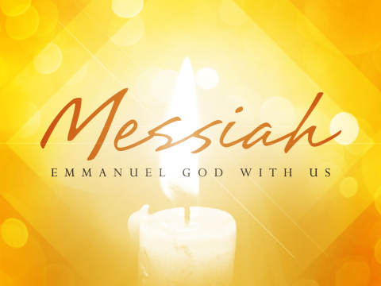

First United Methodist Church
30828 Irene Avenue P.O. Box 688
Lindstrom, Minnesota 55045
Phone: 651.257.4306
Email: firstmethodist@usfamily.net
www.lindstrommethodist.org

December 14, 2014
9:00 a.m.

