Celebrating the Richness of God’s Grace

Proclaiming the Kingdom: beginning in Chisago County

+ Please stand if you are able

To enhance our worship, please turn off all cell phones and electronic devices.
Hearing devices are available at the sound booth.

Prelude and Silent Prayer

Words of Welcome/Attendance Registration

Announcements and Greeting

+Call To Worship Psalm 100 Hymnal #821

+Praise and Worship (please stand or sit as you wish)

Children’s Moment
* Children 3 years – 8th grade are invited to go to Sunday School at this time

+Hymn #61 Come, Thou Almighty King

Bible Reading Matthew 25:31-46

Message The Least Of These
The King will reply, “I tell you the truth, whatever you did for one of the least of these brothers of mine, you did for me.” Matthew 25:40

+Hymn # 3128 (green book) Whatever You Do

Offering Great Is God Choir

+Offering Response (screen) Majesty

Prayer

Video That’s My King!

+Hymn (screen) King of Kings

+Benediction

+Postlude

Thank you for worshiping with us this morning!
This Week’s Calendar…

Monday, November 24
9:00 – 11:00 a.m. Operation Christmas Child Shoe-Box Drop Off Hours
6:00p Bell Choir
4 – 6p Community Dinner at Zion Lutheran Church, Chisago City

Tuesday, November 25
9:15a Women’s Bible Study – lounge

Wednesday, November 26 Thanksgiving Eve
7:00p Worship Service

Thursday, November 27
Thanksgiving – Office Closed

Friday, November 28
Office Closed

Saturday, November 29

Next Sunday, November 30 First Sunday of Advent
9:00a Worship/Sunday School for children and youth
Message based on Luke 1:26-38
10:15a Fellowship
10:30a Intercessory Prayer – chapel

Last week’s offering: $2,309 Budgeted: $3,676

Attendance last Sunday: 74

Carpet Project Giving (Phase Two) : $2,755 Goal: $23,500

Carpet Project: If you would like to make a contribution, please make your check out to First UMC, marking “carpet project” in the memo.

Children at First
- ‘Worship Bags’ are in the foyer for children to borrow
- A Nursery for babies and toddlers is available every Sunday

Prayer Requests: Cole Anderson; Chuck Zimmerman; Roxy Bahn;
Jim McDermott; Pete Grundhoefer; Hannah Irvin; Chuck Loula
Here’s What’s Happening…

Fellowship: Join us for coffee and treats in the fellowship hall following the service.

Our Mission Focus this month: Operation Christmas Child

Mission Envelopes: Mission Envelopes can be found in each pew rack. You are welcome to give to our monthly Mission Offering throughout the month using the designated envelope. Please make your check out to FUMC, marking “Missions” in the memo.

Commitment Cards: Commitment Cards are available on the table in the foyer for anyone who has not had an opportunity to identify their commitment to the church for the year 2015. Please place your completed card in the offering plate or give to Linda Ploog or Patsy Berglund.

Tuesday Morning Women’s Bible Study: We will be watching the video and discussing "The Journey" starting Nov. 25. This will prepare us for what Pastor Dan will be preaching the following Sunday. All women are welcome.

Monday Community Meals: Remember Community Dinner every Monday evening at Zion Church 4-6 p.m. All are welcome. Donations of pink lemonade would be appreciated.

Christmas Caroling and Hayride: On Friday December 12th everyone is invited to join Children and Youth Ministries for a hayride and Christmas caroling through the neighborhood. Supper is at 6:00p (at church), we’ll go caroling, and come back to church afterward to warm up with hot cocoa, dessert, and to play games. Dress warm and bring a blanket for the hayride. If it’s really cold we can bring a few cars along to warm up in. Blessings!
Cheryl Lecy and Laurie Doughty

Let the YOUTH bake Christmas Cookies for you! Funds raised will help kids to camp this summer. Order by Sunday December 7th. Order forms are in the fellowship hall. Pick up your cookies Sunday Dec. 21st in the fellowship hall. Each order will include a variety of cookies/bars.

Defibrillator Purchase: The church would like to purchase a Defibrillator.
The cost is $1800.00. If you would like to donate to this, please write a check to the church and put “Defibrillator” in memo area.

Be a Bell Ringer: Salvation Army Bell Ringers are needed Saturday, Dec. 6 from 11:00 a.m. to 6:00 p.m. at Lindstrom Foods. Sign up is on the bulletin board in the foyer.

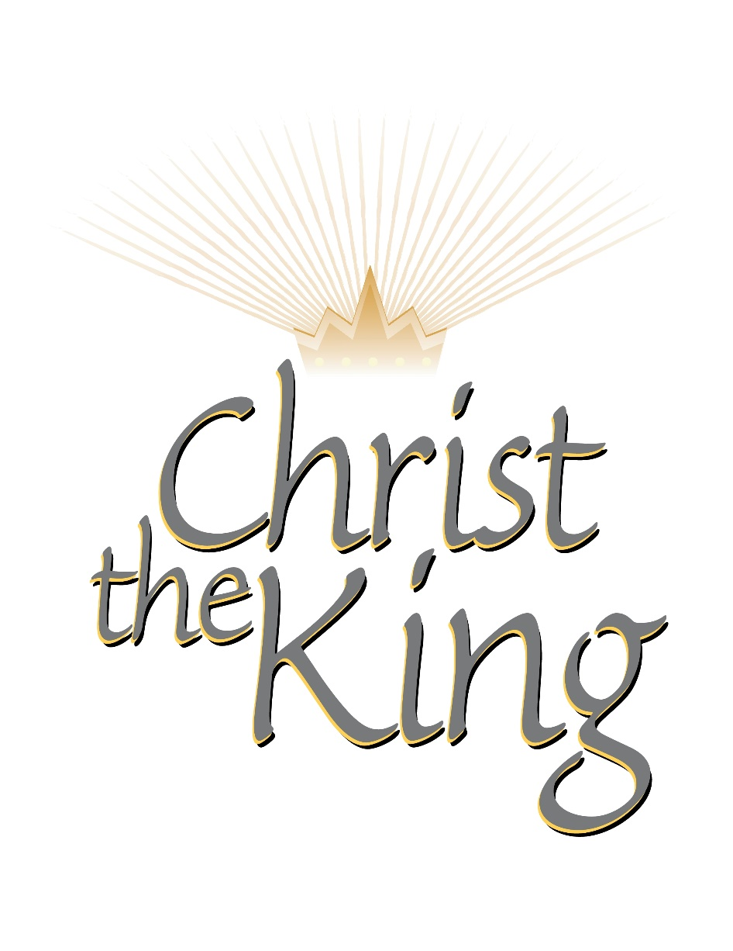

First United Methodist Church
30828 Irene Avenue P.O. Box 688
Lindstrom, Minnesota 55045
Phone: 651.257.4306
Email: firstmethodist@usfamily.net
www.lindstrommethodist.org

November 23, 2014
9:00 a.m.

