Celebrating the Richness of God’s Grace

Proclaiming the Kingdom: beginning in Chisago County

+ Please stand if you are able

To enhance our worship, please turn off all cell phones and electronic devices.
Hearing devices are available at the sound booth.

Prelude and Silent Prayer

Words of Welcome/Attendance Registration

Announcements and Greeting

+Call To Worship Psalm 99 Hymnal #819-820

+Praise and Worship (please stand or sit as you wish)

Sacrament of Holy Baptism Peyton Marie Glader Hymnal #39

* Children 3 years – 8th grade are invited to go to Sunday School at this time

+Hymn #3032 (green book) Across the Lands

Special Music Pearly Gates

Bible Reading

Message Erik and Ele Brohaugh

+Hymn #593 Here I Am, Lord

Offering Trumpet Tune Bell Choir

+Offering Response #494 vs 1 Kum Ba Yah

Prayer

+Hymn #569 We’ve a Story to Tell to the Nations

+Benediction

+Postlude

Thank you for worshiping with us this morning!
This Week’s Calendar…

Monday, October 20
6:00p Bell Choir
4 – 6p Community Dinner at Zion Lutheran Church, Chisago City

Tuesday, October 21 Newsletter Deadline
9:15a Women’s Bible Study – lounge
3:45p Girl Scouts – room 1 & 2
7:00p Trustees – room 1
7:00p Foundation - lounge

Wednesday, October 22
6:00p Adult Bible Study
7:10p Choir

Thursday, October 23
7:00p Women’s Bible Study - lounge
NO Worship Team

Friday, October 24
6:00p Fall Festival
8:00p Youth Dance

Saturday, October 25

Next Sunday, October 26 Stewardship Sunday
9:00a Worship/Sunday School for children and youth
Message based on Matthew 25:14-30
10:15a Fellowship
10:30a Intercessory Prayer – chapel

Last week’s offering: $3,372.30 Budgeted: $3,676

Attendance last Sunday: 117

Carpet Project Giving (Phase Two) : $2,635 Goal: $23,500

Carpet Project: If you would like to make a contribution, please make your check out to First UMC, marking “carpet project” in the memo.

Children at First
- ‘Worship Bags’ are in the foyer for children to borrow
- A Nursery for babies and toddlers is available every Sunday

Prayer Requests: Cole Anderson; Chuck Zimmerman; Roxy Bahn;
Jim McDermott; Pete Grundhoefer
Here’s What’s Happening…

Fellowship: Join us for coffee and treats in the fellowship hall following the service.

Our Mission Focus this month: YWAM, Youth With A Mission, Erik and Ele Brohaugh

Mission Envelopes: Mission Envelopes can be found in each pew rack and in each bulletin.

Baptism: Receiving the Sacrament of Baptism this morning is Peyton Marie Glader, born June 18, 2014, daughter of Britney and Jon Glader.

Family Pathways Food Shelf: Thanksgiving Baskets are given out and each church is asked to donate an item. Our item is a box or bag of stuffing mix. There is a shopping cart in the foyer for your donations.

Volunteer at the Operation Christmas Child Processing Center!
What: Operation Christmas Child Processing Center
Where: TBD (Minneapolis location); When: Monday, December 8, 2014
Time: 5pm-10pm; Only 15 volunteer openings!
Volunteers, thirteen years of age and older, are invited to serve in this fun and critical part of getting these shoebox gifts into the hands of children around the world. Interested? Email Kari Caldwell – jkcadlwell5@gmail.com

Monday Community Meals: Donations of pink lemonade (like Country Time) are needed for the Monday Community Meals. They can be taken to Zion Lutheran Church or left in the food shelf cart at church marked for "Community Meal." Thank you to those who regularly donate pans of bars and to those who volunteer!

Children’s Shop Day, November 15: You can place your donated items in the box in the hallway by room #2. See Laurie Doughty if you have questions.

Fall Festival: Children’s Ministries & Club Rock is hosting a church-wide family event to celebrate Fall! Everyone (and your friends!) is invited to join us Friday October 24th 6-8 pm in the fellowship hall for a night of fun! There will be a costume contest with prizes being awarded to the most creative, best biblical and funniest. Dance for the youth from 8-9 pm.

Get your chili recipes out and decide which one you are going to make. Prizes awarded for the Hottest, Most Original & Best Overall Chili. Activities include a Chili Cook-Off, Games, Crafts, and a Carmel Apple Buffet. Please bring a pot of chili or desert to share. Questions? Contact Erin Thorvaldson at 651-470-7694, Laurie Doughty at 651-257-9083 or Cheryl Lecy at 651-462-5725.

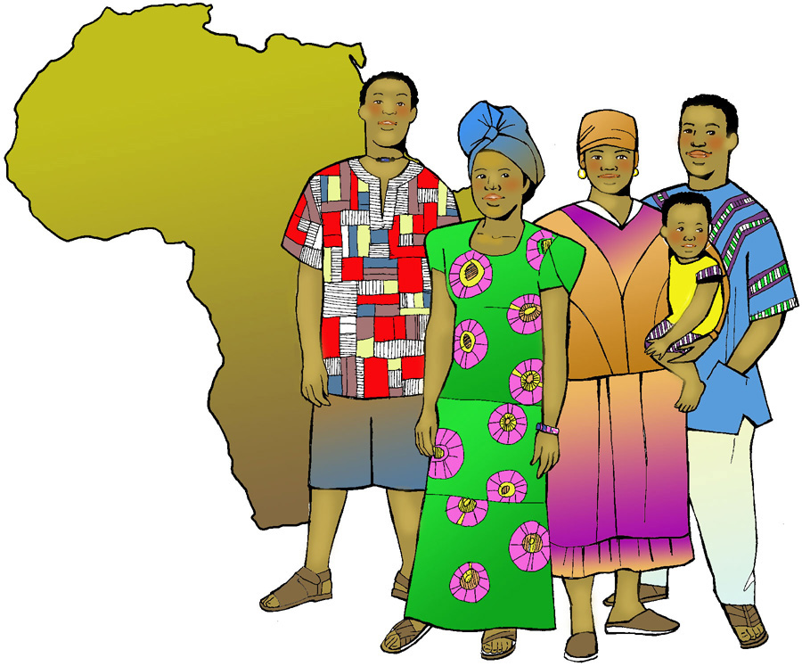

First United Methodist Church
30828 Irene Avenue P.O. Box 688
Lindstrom, Minnesota 55045
Phone: 651.257.4306
Email: firstmethodist@usfamily.net
www.lindstrommethodist.org

October 19, 2014
9:00 a.m.

