Celebrating the Richness of God’s Grace

Proclaiming the Kingdom: beginning in Chisago County

+ Please stand if you are able

To enhance our worship, please turn off all cell phones and electronic devices.
Hearing devices are available at the sound booth.

Prelude and Silent Prayer

Words of Welcome/Attendance Registration

Announcements and Greeting

Mission Sunday NOMADS Irv & Dorothy Lecy

+Call To Worship Psalm 4 Hymnal #741

+Praise and Worship (please stand or sit as you wish)

Children’s Moment
* Children 3 years – 8th grade are invited to go to Sunday School at this time

+Hymn #64 Holy, Holy, Holy! Lord God Almighty

Bible Reading Matthew 20:1-16

Message I Am Generous
“Don’t I have the right to do what I want with my own money?
Or are you envious because I am generous?” Matthew 20:15

+Hymn #121 There’s a Wideness in God’s Mercy

Offering Days of Elijah US Soldiers

+Offering Response (screen) Give Thanks

Prayer

+Hymn #568 Christ for the World We Sing

+Benediction

+Postlude
Thank you for worshiping with us this morning!
This Week’s Calendar…

Monday, September 22
6:30p Bell Choir
4 – 6p Community Dinner at Zion Lutheran Church, Chisago City

Tuesday, September 23

Wednesday, September 24
NO Adult Bible Study
NO Choir

Thursday, September 25
7:00p Women’s Bible Study - lounge
NO Worship Team

Friday, September 26

Saturday, September 27

Next Sunday, September 28
9:00a Worship / Sunday School for children and youth
Message based on Matthew 21:23-32
10:15a Fellowship
10:30a Intercessory Prayer – chapel

Last week’s offering: $2,776 Budgeted: $3,676

Attendance last Sunday: 99

Carpet Project Giving (Phase One) : $14,250! Goal: $14,000

Carpet Project: If you would like to make a contribution, please make your check out to First UMC, marking “carpet project” in the memo.

Children at First
- ‘Worship Bags’ are in the foyer for children to borrow
- A Nursery for babies and toddlers is available every Sunday

Prayer Requests: Cole Anderson; Chuck Zimmerman; Roxy Bahn;
Jim McDermott; Pete Grundhoefer

Here’s What’s Happening…

Fellowship: Join us for coffee and treats in the fellowship hall following the service.

Our Mission Focus this month: NOMADS: Nomads On a Mission Active in Divine Service – (Irv and Dorothy Lecy)

Mission Envelopes: Mission Envelopes can be found in each pew rack. You are welcome to give to our monthly Mission Offering throughout the month using the designated envelope. Please make your check out to FUMC, marking “Missions” in the memo.

Hallway Carpeting: Phase One of the Carpet Project will begin Monday with the laying of carpet in the hallways. No Choir or Adult Bible Study on Wednesday due to the installation process.

Women’s Bible Studies:
Tuesday Morning Women’s Bible Study will begin Tuesday, Sept. 30 at 9:15 a.m. in the church lounge. The Kneeling Christian (the power of prayer) will be the topic. This study will be held every Tuesday and is led by Cindy Kopp. Note beginning date change.

Thursday Evening Women’s Bible Study: Your Beautiful Purpose: Discovering and Enjoying What God Can Do Through You. This study will be held the second and fourth Thursdays of each month at 7:00 p.m. in the church lounge and is led by Char Loula.

Volunteer at the Operation Christmas Child Processing Center!
What: Operation Christmas Child Processing Center
Where: TBD (Minneapolis location); When: Monday, December 8, 2014
Time: 5pm-10pm; Only 15 volunteer openings!
Volunteers, thirteen years of age and older, are invited to serve in this fun and critical part of getting these shoebox gifts into the hands of children around the world. Interested? Email Kari Caldwell – jkcadlwell5@gmail.com

Cradle Rocking (#92): Sunday, October 12, 9:00 a.m. Cradle Rocking is based on a Swedish custom of rocking babies one year and under in celebration. If you know of anyone who would like to have their baby rocked, please contact Sandy Gaudette, 763-954-9394, or the church office.

Save the date: Adopt-a-Highway Clean-Up scheduled for Saturday, Oct. 18, 1:00 p.m.

Children’s Shop Day, November 15: Now collecting items for Children’s Shop Day. It seems early to talk about Christmas, but it takes time to collect all the ‘treasures’ that we have for the children to shop from. See Laurie Doughty if you have questions.

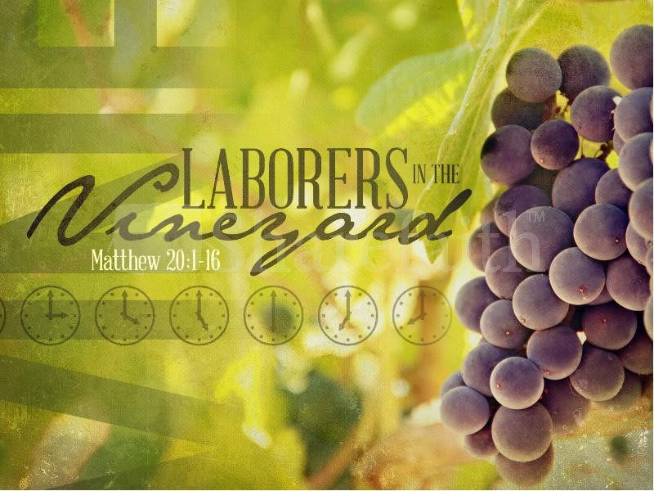

First United Methodist Church
30828 Irene Avenue P.O. Box 688
Lindstrom, Minnesota 55045
Phone: 651.257.4306
Email: firstmethodist@usfamily.net
www.lindstrommethodist.org

September 21, 2014
9:00 a.m.

