Celebrating the Richness of God’s Grace

Proclaiming the Kingdom: beginning in Chisago County

+ Please stand if you are able

To enhance our worship, please turn off all cell phones and electronic devices.
Hearing devices are available at the sound booth.

Prelude and Silent Prayer

Words of Welcome/Attendance Registration

Announcements and Greeting

+Call To Worship Psalm 17:1-7, 15 Hymnal #749

Praise and Worship (please stand or sit as you wish)

Children’s Moment

+Hymn #185 When Morning Gilds the Skies

Scripture Reading Matthew 14:13-21

Message He Had Compassion
When Jesus landed and saw a large crowd, he had compassion on them and
healed their sick. Matthew 14:14

+Hymn #616 Come, Sinners, to the Gospel Feast

Prayer

Service of Holy Communion Hymnal #12
Invitation
Confession and Pardon
Words of Institution
Sharing the Bread and the Cup (gluten free available)
Offering (please bring your gifts as you come to commune)

+Hymn #344 Lord, You Have Come to the Lakeshore

+Benediction

+Postlude
Thank you for worshiping with us this morning!
This Week’s Calendar…

Monday, August 4
4 – 6p Community Dinner at Zion Lutheran Church, Chisago City

Tuesday, August 5

Wednesday, August 6
Pastor Dan out of the office – Covenant Group
3:00 – 6:00 p Retirement Tea for Karen Brohaugh – Chisago County Library

Thursday, August 7
7:30p Worship Team

Friday, August 8

Saturday, August 9

Next Sunday, August 10
OUTDOOR SERVICE (weather permitting)
Please bring your lawn chair or a blanket
10:00a: Worship
Message based on Matthew 14:22-33
11:15a Fellowship

Last week’s offering: $3,406.25 Budgeted: $3,676

Attendance last Sunday: 66

Children at First
- ‘Worship Bags’ are in the foyer for children to borrow
- A Nursery for babies and toddlers is available every Sunday

Prayer Requests: Cole Anderson; Chuck Zimmerman; Roxy Bahn;
Floyd Paurus

Here’s What’s Happening…

Fellowship: Join us for coffee and treats in the fellowship hall following the service.

Our Mission Focus this month: Kids Against Hunger
Mission Envelopes: Mission Envelopes can be found in each pew rack. You are welcome to give to our monthly Mission Offering throughout the month using the designated envelope. Please make your check out to FUMC, marking “Missions” in the memo.

Voting for Carpet: Two carpet samples are on a table in the foyer. You have the opportunity to vote which is your choice for the hallways. Lloyd Jones will be at the table to help you vote. Deadline for voting is TODAY, August 3.

Outdoor Service: Our next outdoor service will be held August 10, 10:00 a.m. at the pavilion (weather permitting). Please bring a lawn chair or blanket.
Note service time change.

School Supplies Needed: Chisago Lakes Area Food Shelf is gathering school supplies for those children who can’t afford them. They will purchase backpacks, fill them with your donations and distribute them at the food shelf the last week in August. A box is located on a table in the foyer for your donations. Deadline is August 22.

Children’s Shop Day, November 15: Now collecting items for Children’s Shop Day. It seems early to talk about Christmas, but it takes time to collect all the ‘treasures’ that we have for the children to shop from. See Laurie Doughty if you have questions.

Club Rock: Club Rock will not meet in August. We will see you again in September! Scott & Cheryl Lecy.

Christian Men’s Group: The Chisago Lakes Christian Men’s Group will be meeting Tuesday, August 5, 8:00 a.m. at the Swedish Inn Restaurant in Center City. School Superintendent Mr. Joe Thimm will be speaking on education matters.

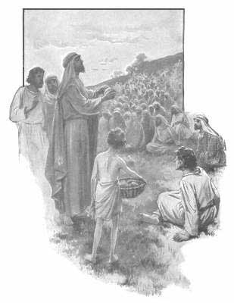

First United Methodist Church
30828 Irene Avenue P.O. Box 688
Lindstrom, Minnesota 55045
Phone: 651.257.4306
Email: firstmethodist@usfamily.net
www.lindstrommethodist.org

August 3, 2014
9:00 a.m.

