Celebrating the Richness of God’s Grace

Proclaiming the Kingdom: beginning in Chisago County

+ Please stand if you are able

To enhance our worship, please turn off all cell phones and electronic devices.
Hearing devices are available at the sound booth.

Prelude and Silent Prayer

Words of Welcome/Attendance Registration

Announcements and Greeting

+Call To Worship Psalm 150 Hymnal #862

Children’s Moment

Hymn Medley
America (My Country, ‘Tis of Thee) Hymnal #697
America the Beautiful Hymnal #696
+To God Be the Glory Hymnal #98

Bible Reading Romans 7:14-25

Message Who Will Rescue Me
What a wretched man I am! Who will rescue me from this body of death?
Thanks be to God—through Jesus Christ our Lord! Romans 7:24-25

+Hymn (screen) Just a Closer Walk with Thee

Prayer

Service of Holy Communion Hymnal #12
See Insert
Offering (please bring your gifts as you come to commune)

+Hymn #431 Let There Be Peace on Earth

+Benediction

+Song #3183 (green book) As We Go

+Postlude

Thank you for worshiping with us this morning!
This Week’s Calendar…

Monday, July 7
4 – 6p Community Dinner at Zion Lutheran Church, Chisago City

Tuesday, July 8
6:30p Men’s Softball ~ Ki-Chi-Saga Park field 2

Wednesday, July 9

Thursday, July 10
9:15a Hope Circle
7:00p Worship Team

Friday, July 11

Saturday, July 12

Next Sunday, July 13
OUTDOOR SERVICE (weather permitting)
Please bring a lawn chair
9:00a Worship / Rev. John C. Blackford Scholarships Presented
10:15a Fellowship
10:30a Intercessory Prayer – chapel

Last week’s offering: $3,255 Budgeted: $3,676

Attendance last Sunday: 75

Children at First
- ‘Worship Bags’ are in the foyer for children to borrow
- A Nursery for babies and toddlers is available every Sunday

Prayer Requests: Cole Anderson; Chuck Zimmerman; Roxy Bahn;
Duane Jones

Here’s What’s Happening…

Fellowship: join us for coffee and treats in the fellowship hall following the service.

Our Mission Focus this month: Restoring the Heart Ministries
Mission Envelopes: Mission Envelopes can be found in each pew rack. You are welcome to give to our monthly Mission Offering throughout the month using the designated envelope. Please make your check out to FUMC, marking “Missions” in the memo.

Crescent Beach Cemetery: Our cemetery, located between Lindstrom and Center City, now has a rain barrel for watering your plants at the cemetery. Please feel free to water other plants while you are there.

Carpet Project: If you would like to help, please make your check out to First UMC, marking “carpet project” in the memo.

Office Hours: Office hours have changed to 8:00 a.m. – 2:30 p.m. Monday – Friday.

Men’s Softball: All are welcome to come out and cheer for the home team! Tuesday evenings at Ki-Chi-Saga Park, Glader Blvd, Lindstrom.

Outdoor Service: Our next outdoor service will be held July 13, 9:00 a.m. at the pavilion (weather permitting). Please bring a lawn chair or blanket.

Scholarships: Rev. John C. Blackford Scholarships will be presented Sunday, July 13 by a member of the Foundation Board.

Upper Room Devotionals: The Upper Room Devotional for July/August is on the table in the foyer.

Online Bill Pay…do you use your computer to pay your bills on-line? If you do, you may want to send your church offering/pledge through the same on-line bill pay service. You can set up an automatic payment plan or a one time contribution. It’s easy:
* First, login to your bill pay account
* Select Add a Bill
* Select Create an account without an account number
(use the address and phone number below)
First United Methodist Church
P.O. Box 688
Lindstrom, MN 55045
651-257-4306

Please see Greg Oien or Scott Lecy if you have any questions.

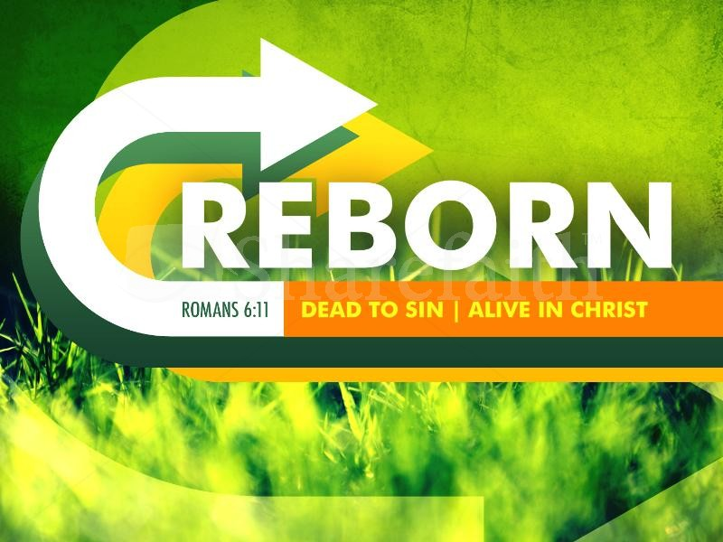

First United Methodist Church
30828 Irene Avenue P.O. Box 688
Lindstrom, Minnesota 55045
Phone: 651.257.4306
Email: firstmethodist@usfamily.net
www.lindstrommethodist.org

July 6, 2014
9:00 a.m.

