Celebrating the Richness of God’s Grace

Proclaiming the Kingdom: beginning in Chisago County

+ Please stand if you are able

To enhance our worship, please turn off all cell phones and electronic devices.
Hearing devices are available at the sound booth.

Prelude and Silent Prayer

Words of Welcome/Attendance Registration

Announcements and Greeting

Call to Worship

Praise and Worship (please stand or sit as you wish)

Children’s Moment

+Hymn #98 To God Be the Glory

Bible Reading Luke 16:19-31

Message Even If
He said to them, “If they do not listen to Moses and the Prophets, they will not be convinced even if someone rises from the dead.” Luke 19:31

+Hymn #277 Tell Me the Stories of Jesus

Offering Ancient Words Choir

+Offering Response #176 Majesty, Worship His Majesty

Prayer

+Hymn #569 We’ve a Story to Tell to the Nations

+Benediction

+Postlude

Thank you for worshiping with us this morning!
This Week’s Calendar…

Monday, September 26
4 – 6p Community Meal – Zion Lutheran Church, Chisago City
6:15p Bell Choir

Tuesday, September 27
9:15a Women’s Bible Study - lounge

Wednesday, September 28
6:00p Adult Bible Study – lounge
7:00p Choir

Thursday, September 29
NO Worship Team Rehearsal

Friday, September 30

Saturday, October 1

Next Sunday, October 2 World Communion Sunday / Confirmation
9:00a Worship / Sunday School
Message based on Luke 17:1-10
10:15a Fellowship
10:30a Intercessory Prayer – chapel

Last week’s offering: $1,979 Budgeted Weekly: $3,618
Monthly giving (Sept).: $7,604 Budgeted Monthly: $15,679

Attendance last Sunday: 110

Carpet Project Giving (Phase Two): $8,984 Goal: $23,500
Carpet Project: If you would like to make a contribution, please make your check out to First UMC, marking “carpet project” in the memo.

Children at First
- ‘Worship Bags’ are in the foyer for children to borrow
- A Nursery for babies and toddlers is available every Sunday

Please Pray For: Cole Anderson; Doris Brand; Steve Hernick;
Jim McDermott; David Heldt; Isaac Mitchell; Britt, Kelvin & Baby;
Roxy Bahn

Cradle Rocking #94: Sunday, Oct. 9, 9:00 a.m. This event is based on a Swedish custom of rocking babies one year and under in a cradle while children sing songs over them. If you or anyone you know would like to have their baby rocked, please contact Sandy Gaudette, 651-213-3218.
Here’s What’s Happening…

Fellowship: Join us for coffee and treats in the fellowship hall following the service.

Our Mission Focus this month: NOMADS
Nomads On a Mission Active in Divine Service
NOMADS demonstrate God’s love through their work and by listening to the people with whom they work. They do new construction, remodeling, and repairs for churches, children’s homes, camps, colleges, outreach missions and disaster rebuilding.

Mission Envelopes: Mission Envelopes can be found in each pew rack. You are welcome to give to our monthly Mission Offering throughout the month using the designated envelope. Please make your check out to FUMC, marking “Missions” in the memo.

Mobile Food Packing: There will be a Feed My Starving Children mobile food packing event at Lakes Free Church in Lindstrom on Oct. 14 and 15. They have saved 10 slots for Methodists on Saturday Oct. 15 from 9am to 11am. There is a sign-up sheet on the hallway bulletin board for those who want to participate at that time. There are also cards on the hallway table with details about the event and contact info for those who want to participate at another time.

Wednesday Night Adult Bible Study: The study will be held at 6:00pm.

Wednesday Night Family Dinner: Wednesday night dinners will resume this fall!! Starting OCTOBER 5th, please join us for a family style meal every Wednesday at 5:00 pm. Free will offering. There is a sign up sheet in the fellowship hall for anyone who would like to cook and serve a meal on a Wednesday night. Please see Mark or Wendy Vanderwerf for more information. All are welcome!!!

Women’s Bible Study: The study will be held Tuesdays, 9:15 – 11:00a beginning September 27. We’ll be studying the Book of Acts. Contact Cindy Kopp if you have questions, 257-8526.

Annual Highway Clean—up: We are officially part of the Adopt-A-Highway project. Our cleaning day has been set for Saturday, October 1. Meet at church at 1:00 p.m. to get official vests and bags, which we must use. Our portion of the highway is Cnty Road 19, from Cnty 14 to Karmel – 2 miles. Thanks to all who are willing to come out to help make our community clean and pleasant. Questions? Call Lois Anderson, 257-5547.

Giving Envelopes: We are getting ready to order 2017 giving envelopes.
We encourage use of the envelopes for your contributions. If you don’t have giving envelopes now and would like a booklet, please let the office or Linda Ploog know by Sunday, October 9. Thank you!

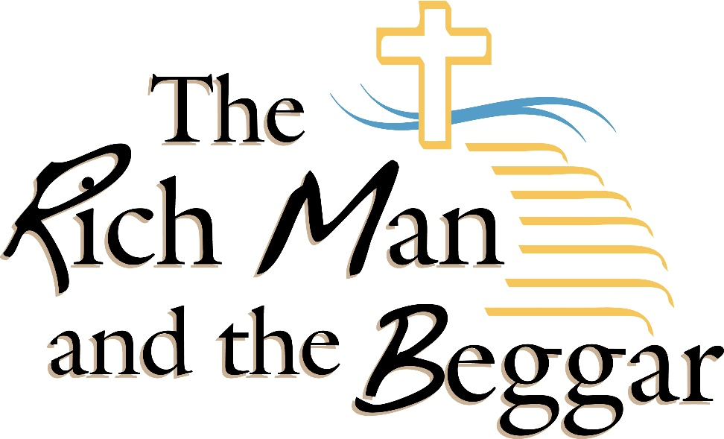

First United Methodist Church
30828 Irene Avenue P.O. Box 688
Lindstrom, Minnesota 55045
Phone: 651.257.4306
Email: firstmethodist@usfamily.net
www.lindstrommethodist.org

September 25, 2016
9:00 a.m.

