Celebrating the Richness of God’s Grace

Proclaiming the Kingdom: beginning in Chisago County

To enhance our worship, please turn off all cell phones and electronic devices.

Our Mission Sunday mission focus this month is MN Adult & Teen Challenge, whose choir is leading our worship service today with music and testimonies. Following the service, the students will be available to answer questions about their personal experiences with MN Adult & Teen Challenge. Your gifts will help support this life-changing endeavor. Please make your check out to First United Methodist Church, marking “Missions” in the memo. Thank you!

About MN Teen Challenge (from their website):
For 30 years, MN Adult & Teen Challenge has been restoring hope to teens and adults struggling with drug and alcohol addiction. They are one of the largest, most effective, and most affordable programs in the nation with campuses in Mpls., Brainerd, Duluth and soon to open: Rochester, MN.

They utilize a comprehensive, faith-based approach in the short-term licensed treatment and long-term recovery programs, allowing them to effectively serve individuals with a broad spectrum of addiction issues: from those seeking treatment for the first time, to those who have been struggling with addiction for many years.

MN Adult & Teen Challenge differs from other recovery programs in their emphasis on the physical, emotional, and spiritual needs of clients, the length of involvement with clients, and their focus on providing support long after the client leaves their care. The Adult & Teen Challenge model truly enables program participants to experience hope, healing and freedom in their lives.

MN Adult & Teen Challenge is one of the largest of more than 150 Teen Challenge centers in the United States and 250 centers worldwide. currently, MN Adult & Teen Challenge houses over 400 individuals in five residences in Mpls., one residence in Duluth and one residence in Brainerd.

MN Adult & Teen Challenge began in 1958 when Rev. David Wilkerson set out for New York to minister to teenage gang members. It was the conversion of notorious gang leader Nicky Cruz that laid the foundation for the beginnings of Teen Challenge ministries. Cruz’s conversion is chronicled in the best-selling novel The Cross and the Switchblade.

Thank you for worshiping with us this morning!
This Week’s Calendar…

Monday, July 10
4 – 6p Community Dinner at Zion Lutheran Church, Chisago City

Tuesday, July 11
6:30p Men’s Softball – Ki-Chi-Saga Park field #3

Wednesday, July 12

Thursday, July 13
Hope Circle will not be meeting in July

Friday, July 14

Saturday, July 15

Next Sunday, July 16
Doris Brand’s 102nd Birthday!
9:00a Worship / Presentation of Rev. John C. Blackford Scholarships
10:15a Fellowship
10:30a Intercessory Prayer – chapel

Last week’s offering: $5,290 Budgeted Weekly: $3,618
Monthly giving (July): $5,290 Budgeted Monthly: $15,679

Attendance last Sunday: 68

Carpet Project Giving (Phase Two): $11,500 Goal: $23,500

Carpet Project: If you would like to make a contribution, please make your check out to First UMC, marking “carpet project” in the memo.

Children at First
- ‘Worship Bags’ are in the foyer for children to borrow

Please Pray For: Cole Anderson; Doris Brand; Roxy Bahn; Olga Determan;
Char Loula’s father; Lynne Wilkerson’s father; Glenn & Marlys Polzine

Here’s What’s Happening…

Fellowship…

Join us for a brunch in the fellowship hall following the service.

Our Mission Focus this month: MN Adult & Teen Challenge
From their website:
For 30 years, MN Adult and Teen Challenge has been restoring hope to people struggling with drug and alcohol addiction. In addition to our effective and affordable shorter-term programs, Life Renewal, and our distinctive long-term faith-based recovery program, we have extensive prevention and transitional/aftercare services.

Mission Envelopes: Mission Envelopes can be found in each pew rack. You are welcome to give to our monthly Mission Offering throughout the month using the designated envelope. Please make your check out to FUMC, marking “Missions” in the memo.

Family Pathways Food Shelf: The Food Shelf is always in need of non-perishable food, especially when children are out of school over the summer. Items needed: Spaghetti O’s, Mac n Cheese, Vegetable Beef Soup, Fruit Snacks, Tomato Soup, Chicken Noodle Soup, Canned Fruit, Canned Vegetables and child-friendly snacks. There is a grocery cart in the foyer for your donations.

Energy Committee: To help with our electrical cost, we need to form an Energy Committee. If you would like to be on this committee, please contact Mark Vanderwerf or Lloyd Jones. Thank you!

Birthday!: Doris Brand turns 102 on July 16! A birthday card is in the fellowship hall, if you would like to sign it.

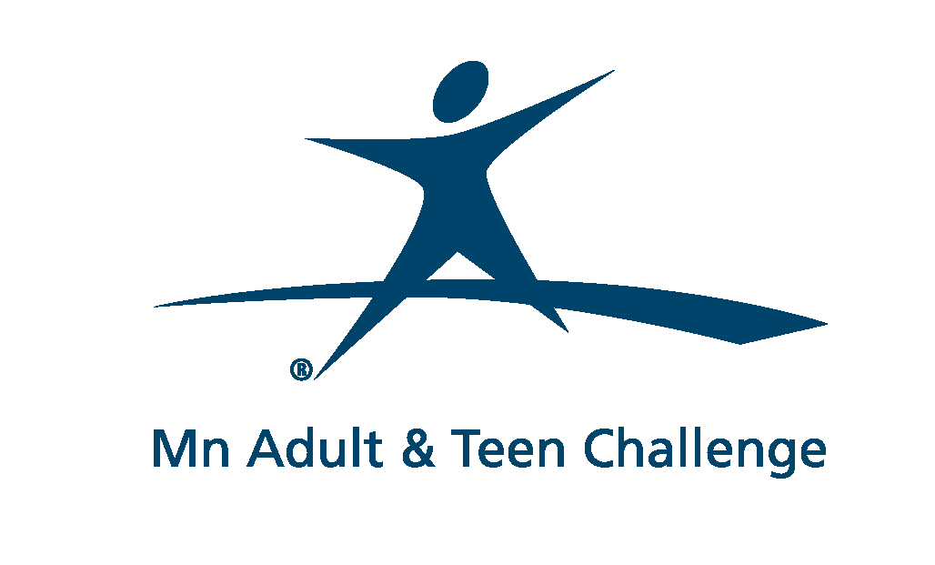

First United Methodist Church
30828 Irene Avenue P.O. Box 688
Lindstrom, Minnesota 55045
Phone: 651.257.4306
Email: firstmethodist@usfamily.net
www.lindstrommethodist.org

July 9, 2017
9:00 a.m.

