Celebrating the Richness of God’s Grace

Proclaiming the Kingdom: beginning in Chisago County

+ Please stand if you are able

To enhance our worship, please turn off all cell phones and electronic devices.
Hearing devices are available at the sound booth.

Prelude and Silent Prayer

Words of Welcome/Attendance Registration

Announcements and Greeting

Call to Worship

Praise and Worship (please stand or sit as you wish)

Children’s Moment

+Hymn #64 Holy, Holy, Holy! Lord God Almighty

Bible Reading Romans 8:12-25

Message Spirit of Adoption
For you did not receive a spirit that makes you a slave again to fear, but you received the Spirit of (adoption). And by him we cry, “Abba, Father.” Romans 8:15

+Hymn #419 I Am Thine, O Lord

Offering

+Offering Response #99 My Tribute

Prayer

+Hymn #714 I Know Whom I Have Believed

+Benediction

+Postlude

Thank you for worshiping with us this morning!
This Week’s Calendar…

TODAY, July 23
5:00p Unidos en Cristo Ultreya – fellowship hall

Monday, July 24
4 – 6p Community Meal – Zion Lutheran Church, Chisago City

Tuesday, July 25
6:30p Men’s Softball – Ki Chi Saga Park, field 2

Wednesday, July 26
7:00p Worship Team

Thursday, July 27

Friday, July 28

Saturday, July 29
8:00a Softball Tournament – Ki-Chi-Saga Park

Next Sunday, July 30
9:00a Worship
Message based on Romans 8:26-39
10:15a Fellowship
10:15a Intercessory Prayer – chapel

Last week’s offering: $1,861.25 Budgeted Weekly: $3,510
Monthly giving (July): $17,667.25 Budgeted Monthly: $15,208

Attendance last Sunday: 96

Carpet Project Giving (Phase Two): $19,212 Goal: $23,500

Carpet Project: If you would like to make a contribution, please make your check out to First UMC, marking “carpet project” in the memo.

Children at First
- ‘Worship Bags’ are in the foyer for children to borrow

Please Pray For: Cole Anderson; Doris Brand; Roxy Bahn; Olga Determan;
Char Loula’s father; Lynne Wilkerson’s father; Glenn & Marlys Polzine
Here’s What’s Happening…

Fellowship: Join us for coffee & treats in the fellowship hall following the service.

Our Mission Focus this month: MN Adult & Teen Challenge
From their website:
For 30 years, MN Adult and Teen Challenge has been restoring hope to people struggling with drug and alcohol addiction. In addition to our effective and affordable shorter-term programs, Life Renewal, and our distinctive long-term faith-based recovery program, we have extensive prevention and transitional/aftercare services.

Mission Envelopes: Mission Envelopes can be found in each pew rack. You are welcome to give to our monthly Mission Offering throughout the month using the designated envelope. Please make your check out to FUMC, marking “Missions” in the memo.

Family Pathways Food Shelf: The Food Shelf is always in need of non-perishable food, especially when children are out of school over the summer. Items needed: Spaghetti O’s, Mac n Cheese, Vegetable Beef Soup, Fruit Snacks, Tomato Soup, Chicken Noodle Soup, Canned Fruit, Canned Vegetables and child-friendly snacks. There is a grocery cart in the foyer for your donations.

Energy Committee: To help with our electrical cost, we need to form an Energy Committee. If you would like to be on this committee, please contact Mark Vanderwerf or Lloyd Jones. Thank you!

Offering counters needed!: Two counters are required each Sunday. One counter takes the lead role while the other person assists. Commitment would be about 45 minutes one Sunday per month after the service. We will train!
If you are interested please contact Linda Ploog 651-257-3323.

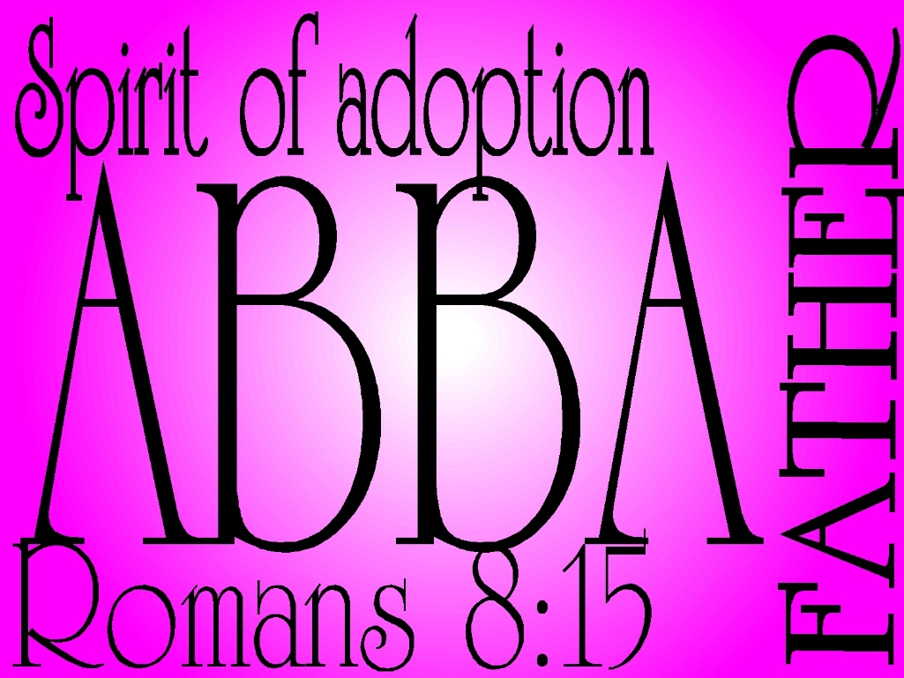

First United Methodist Church
30828 Irene Avenue P.O. Box 688
Lindstrom, Minnesota 55045
Phone: 651.257.4306
Email: firstmethodist@usfamily.net
www.lindstrommethodist.org

July 23, 2017
9:00 a.m.

