Celebrating the Richness of God’s Grace

Proclaiming the Kingdom: beginning in Chisago County

+ Please stand if you are able

To enhance our worship, please turn off all cell phones and electronic devices.
Hearing devices are available at the sound booth.

Prelude and Silent Prayer

Words of Welcome/Attendance Registration

Announcements and Greeting

Call to Worship

+Hymn #3101 (Green Book) Love Lifted Me

Children’s Moment

+Hymn #133 Leaning on the Everlasting Arms

Bible Reading Matthew 10:24-39

Message Not Above
“A student is not above his teacher, nor a servant above his master.” Matthew 10:24

+Hymn #130 God Will Take Care of You

Offering

+Offering Response #95 Praise God, from Whom All Blessings Flow

Prayer

+Hymn #569 We’ve a Story to Tell to the Nations

+Benediction

+Postlude

Thank you for worshiping with us this morning!
This Week’s Calendar…

TODAY, June 25
1:00 – 5:00p Family Praise Fest!

Monday, June 26
4 – 6p Community Meal – Zion Lutheran Church, Chisago City

Tuesday, June 27
6:30p Men’s Softball – Ki Chi Saga Park, field 3

Wednesday, June 28
7:00p Worship Team

Thursday, June 29

Friday, June 30
Carol Schmidt on vacation

Saturday, July 1

Next Sunday, July 2
9:00a Worship
Message based on Genesis 22:1-14
10:15a Fellowship
10:15a Intercessory Prayer – chapel

Monday, July 3
Carol Schmidt on vacation

Tuesday, July 4
Office Closed

Last week’s offering: $3,158 Budgeted Weekly: $3,510
Monthly giving (June): $8,883 Budgeted Monthly: $15,208

Attendance last Sunday: 101

Carpet Project Giving (Phase Two): $11,455 Goal: $23,500

Carpet Project: If you would like to make a contribution, please make your check out to First UMC, marking “carpet project” in the memo.

Children at First
- ‘Worship Bags’ are in the foyer for children to borrow
Here’s What’s Happening…

Fellowship: Join us for coffee & treats in the fellowship hall following the service.

Our Mission Focus this month:
MN Annual Conference Reach*Renew*Rejoice
The Minnesota Conference’s vision is for all congregations to live out God’s call to grow in love of God and neighbor, reach new people, and heal a broken world. The Conference’s seven-year plan for congregational development has two components: starting new churches and growing existing churches by equipping them to increase vitality.

Mission Envelopes: Mission Envelopes can be found in each pew rack. You are welcome to give to our monthly Mission Offering throughout the month using the designated envelope. Please make your check out to FUMC, marking “Missions” in the memo.

Sermon videos online: Did you miss a Sunday worship service? Sermon videos are on our website. Go to www.lindstrommethodist.org and click on the Worship tab at the top of the page. Then click on the Sermon tab. You will be able to read the sermon or view the video. Be sure to check out the rest of the website for more information.

Family Praise Fest: TODAY, June 25th, 1:00 – 5:00p. Family Praise Fest 2017!

Bed Sheets Needed: We are making new angel costumes for the Living Nativity. If you'd like to donate to this cause, you can drop off new or slightly used white sheets in the office or see Cindy Kopp or Linda Ploog.

Please Pray For: Cole Anderson; Doris Brand; Roxy Bahn; Olga Determan;
Char Loula’s father; Lynne Wilkerson’s father

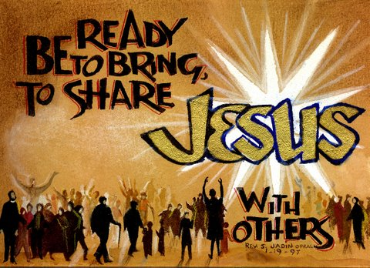

First United Methodist Church
30828 Irene Avenue P.O. Box 688
Lindstrom, Minnesota 55045
Phone: 651.257.4306
Email: firstmethodist@usfamily.net
www.lindstrommethodist.org

June 25, 2017
9:00 a.m.

