Celebrating the Richness of God’s Grace

Proclaiming the Kingdom: beginning in Chisago County

+ Please stand if you are able

To enhance our worship, please turn off all cell phones and electronic devices.
Hearing devices are available at the sound booth.

Prelude and Silent Prayer

Words of Welcome/Attendance Registration

Announcements and Greeting

Mission Moment The Gideons

Lighting of the Advent Candle The RempelEwert Family

Praise and Worship (please stand or sit as you wish)

Children’s Moment
* Children 2 years- 8th grade are invited to go to Sunday School at this time
Grades 3rd -8th do not have Sunday school the first Sunday of the month

+Hymn #224 Good Christian Friends, Rejoice

Bible Reading Luke 1:26-38

Message A Son
“You will be with Child and give birth to a son, and you are to give him the name Jesus.”
Luke 1:31

+Hymn #217 Away in a Manger

Offering As Lately We Watched Bell Choir

+Offering Response (screen) The Christmas Doxology

Prayer

+Hymn #240 Hark! the Herald Angels Sing

+Benediction

+Postlude

Thank you for worshiping with us this morning!
This Week’s Calendar…

Monday, December 18
Christmas Dinner Reservations deadline
4 – 6p Community Meal – Zion Lutheran Church, Chisago City
6:00p Bell Choir
6:30p A Brush with Kindness - lounge

Tuesday, December 19 Newsletter Deadline
No meetings scheduled in December

Wednesday, December 20
6:00p Choir
7:00p Worship Team

Thursday, December 21

Friday, December 22

Saturday, December 23

Next Sunday, December 24 4th Sunday of Advent/ Christmas Eve
9:00a Worship / NO Sunday School
Message based on Matthew 1:18-25
10:15a Fellowship
4:30p Christmas Eve Candlelight Worship Service

Monday, December 25 Christmas Day!
Office Closed
12:00 – 1:15p Christmas Dinner Served
No Community Meal served at Zion Lutheran Church today

Last week’s offering: $4,876 Budgeted Weekly: $3,510
Monthly giving (Dec.): $10,739 Budgeted Monthly: $15,208

Attendance last Sunday: 112

Carpet Project Giving (Phase Two): $22,780

Carpet Project: We are currently short $2,847 to complete this project.
If you would like to make a contribution, please make your check out to
First UMC, marking “carpet project” in the memo.

Children at First
- ‘Worship Bags’ are in the foyer for children to borrow
- A Nursery for babies and toddlers is available every Sunday

Please Pray For: Cole Anderson; Doris Brand; Olga Determan;
Babe Anderson; Jon Determan
Here’s What’s Happening…

Fellowship: Join us for coffee & treats in the fellowship hall following the service.

Our Mission Focus this month: Gideons
Having God’s Word can and does lead people to faith in Christ, and those new Christians then grow by studying their Scriptures and even use them to share their faith with others.

Mission Envelopes: Mission Envelopes can be found in each pew rack. You are welcome to give to our monthly Mission Offering throughout the month using the designated envelope. Please make your check out to FUMC, marking “Missions” in the memo.

Church Wireless Network Change: We have upgraded the Sanctuary wireless network to have faster access. The two new network names are “disciples12” and “disciples12-5” you may join either network using the password “12disciples” (no quotes).

Christmas Cookies: Christmas Cookies will be available for pick up TODAY after church. All money goes for children and youth campership and missions.

End of Year Giving: If you wish to make an end-of-the year charitable donation to First UMC, it will need to be received NO LATER than Sunday, December 31 to be included in your 2017 contribution. If you, or your bank, are mailing your final 2017 contribution, please allow plenty of time for it to be delivered to the church by Dec. 29. If you would like to know the balance of your pledge, please talk with Linda Ploog.

Offering Envelopes for 2018: Please pick up your Offering Envelopes for 2018 on the table in the foyer. If you don’t see a booklet for your family, and would like one, please contact the office, 257-4306.

Christmas Dinner: All are invited to our 27th Annual Christmas Day Dinner serving from 12:00 – 1:15p on Christmas Day. Please call 651-257-4306 by Monday, Dec. 18 to let us know you are coming. If you would like to help or donate food, please call Lois at 651-213-1036.

Adult New Year’s Eve Day Party: The party has been cancelled.

“Puzzles, Pie and Potato Soup”: Friday, January 26; 6-9 PM. To join in the fun: Enter a team of 4 in the jigsaw puzzle contest. $20 entry fee and fabulous prizes for the winners. Deadline to enter is Sunday January 14. Call the church office to sign up, 257-4306 AND Enjoy a bowl of homemade potato soup and pie. Admission fee: $2 per person at the door for soup and pie.

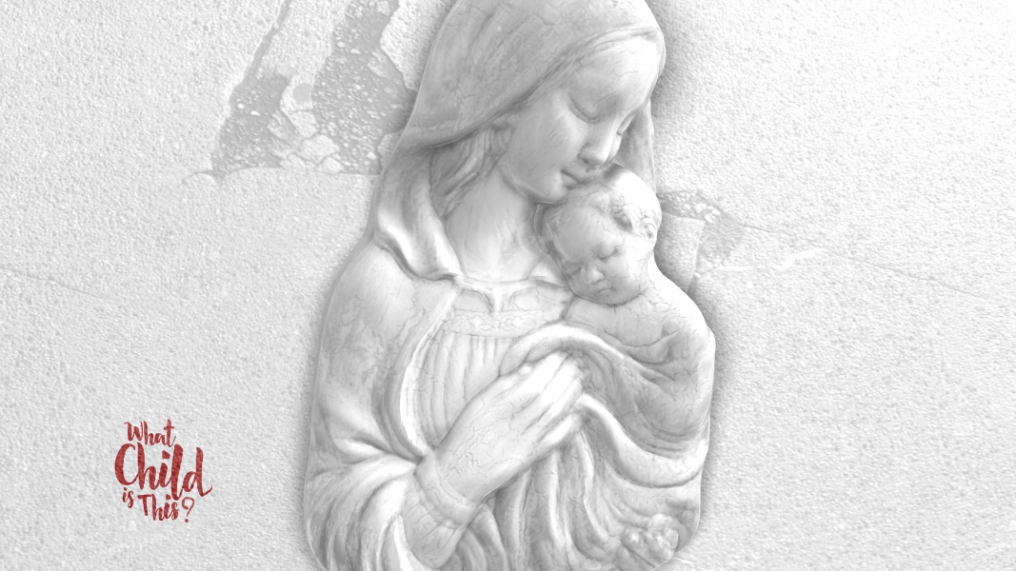

First United Methodist Church
30828 Irene Avenue P.O. Box 688
Lindstrom, Minnesota 55045
Phone: 651.257.4306
Email: firstmethodist@usfamily.net
www.lindstrommethodist.org

December 17, 2017
9:00 a.m.

