Celebrating the Richness of God’s Grace

Proclaiming the Kingdom: beginning in Chisago County

+ Please stand if you are able

To enhance our worship, please turn off all cell phones and electronic devices.
Hearing devices are available at the sound booth.

Prelude and Silent Prayer

Words of Welcome/Attendance Registration

Announcements and Greeting

Call to Worship

Praise and Worship (please stand or sit as you wish)

Children’s Moment
* Children 2 years – 5th grade are invited to go to Sunday School at this time

+Hymn #145 Morning Has Broken

Bible Reading John 9:1-41

Message Now I See
He replied, “Whether he is a sinner or not, I don’t know.
One thing I do know. I was blind but now I see.” John 9:25

+Hymn #369 Blessed Assurance

Offering Just a Little Talk With Jesus Choir

+Offering Response #99 My Tribute

Prayer

+Hymn #370 Victory in Jesus

+Benediction

+Postlude

Thank you for worshiping with us this morning!
This Week’s Calendar…

Monday, March 27
4 – 6p Community Meal – Zion Lutheran Church, Chisago City
6:15p Bell Choir

Tuesday, March 28
9:15a Women’s Bible Study

Wednesday, March 29
5:30p Family Dinner
5:30p Children’s Bell Choir
6:00p Adult Bible Study – lounge
7:00p Choir
8:15p Worship Team

Thursday, March 30

Friday, March 31

Saturday, April 1

Next Sunday, April 2 Fifth Sunday in Lent
9:00a Worship / Sunday School
Message based on John 11:1-44
10:15a Fellowship
10:15a Intercessory Prayer – chapel

Last week’s offering: $1,527 Budgeted Weekly: $3,510
Monthly giving (March): $9,122 Budgeted Monthly: $15,208

Attendance last Sunday: 101

Carpet Project Giving (Phase Two): $10,536 Goal: $23,500
Carpet Project: If you would like to make a contribution, please make your check out to First UMC, marking “carpet project” in the memo.

Children at First
- ‘Worship Bags’ are in the foyer for children to borrow
- A Nursery for babies and toddlers is available every Sunday

Please Pray For: Cole Anderson; Doris Brand; Roxy Bahn
Here’s What’s Happening…

Fellowship: Join us for coffee & treats in the fellowship hall following the service.

Thank you:
To Our Church Family:
Thank you for all your love, care and prayers for Jim (and me) during his long journey. Your thoughtfulness and kindness was truly appreciated.
Blessings, Pat McDermott

Our Mission Focus this month: UMCOR. UMCOR responds to natural or civil disasters of such magnitude that they overwhelm a community’s ability to recover on its own. Through UMCOR, United Methodists extend loving care to people within the United States, as well as those in Africa, Asia, Central and South America, and the Caribbean. These beneficiaries are seen as partners, not victims, and UMCOR works to empower them. Wherever possible, UMCOR cooperates with other aid organizations to extend its reach.

Mission Envelopes: Mission Envelopes can be found in each pew rack. You are welcome to give to our monthly Mission Offering throughout the month using the designated envelope. Please make your check out to FUMC, marking “Missions” in the memo.

Sign up for Youth Summer Camp: Grades 1 through 12 sign up for summer camp in the fellowship hall. Contact Cheryl Lecy for more information.

Candles: "Sponsor" a candle in honor or memory of a loved one. $78 will cover the cost of a permanent candle on the front wall. Please contact the church office or talk to Cindy Kopp if interested.

Bell Choir: Rehearsals will resume Monday, March 27, 6:15 p.m.

Easter Carnival: Volunteers are needed for our annual Easter Carnival for the community, held Saturday, April 8, 10:00 – 11:30 a.m. Please see Katie Leadholm if you can help. Also, see the poster in the fellowship hall and grab some eggs to fill!

April:
Palm Sunday ~ 9:00 a.m. Worship
Maundy Thursday ~ 7:00 p.m. Worship with Communion
Easter Sunday Celebration! ~ 7:00 – 8:45a Breakfast
9:00a Celebration Worship
(no Sunday School)

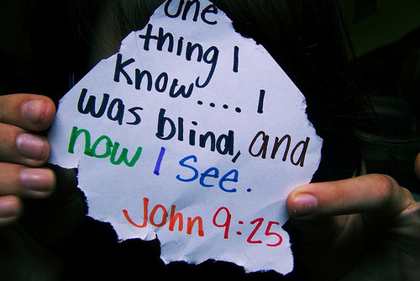

First United Methodist Church
30828 Irene Avenue P.O. Box 688
Lindstrom, Minnesota 55045
Phone: 651.257.4306
Email: firstmethodist@usfamily.net
www.lindstrommethodist.org

March 26, 2017
9:00 a.m.

