Celebrating the Richness of God’s Grace

Proclaiming the Kingdom: beginning in Chisago County

+ Please stand if you are able

To enhance our worship, please turn off all cell phones and electronic devices.
Hearing devices are available at the sound booth.

Prelude and Silent Prayer

Words of Welcome/Attendance Registration

Announcements and Greeting

Lighting of the Advent Candle The Jon Glader Family

Praise and Worship (please stand or sit as you wish)

Children’s Moment
* Children 2 years – 5th grade are invited to go to Sunday School at this time

+Hymn #211 vss 1-4 O Come, O Come, Emmanuel

Bible Reading Genesis 3:1-21

Message God Made Garments
The Lord God made garments of skin for Adam and his wife and clothed them.
Genesis 3:21

+Hymn #202 People, Look East

Offering Come, Emmanuel Choir

+Offering Response #204 Emmanuel, Emmanuel

Prayer

+Hymn #213 Lift Up Your Heads, Ye Mighty Gates

+Benediction

+Postlude

Thank you for worshiping with us this morning!
This Week’s Calendar…

Monday, November 28
4 – 6p Community Meal – Zion Lutheran Church, Chisago City
6:15p Bell Choir
7:15p Living Nativity Planning Meeting

Tuesday, November 29
9:15a Women’s Bible Study – lounge

Wednesday, November 30
5:00p Family Dinner
5:30p Children’s Bell Choir
6:00p Adult Bible Study – lounge
7:00p Choir
8:15p Worship Team

Thursday, December 1
6:00p Decorating the church

Friday, December 2
2:30p Club Rock

Saturday, December 3

Next Sunday, December 4 2nd Sunday of Advent
9:00a Worship / Sunday School
Message based on Matthew 3:1-12
10:15a Fellowship
10:30a Intercessory Prayer – chapel
2:00 – 6:00p Christmas Open House at Dan & Laurie’s home

Last week’s offering: $3,286 Budgeted Weekly: $3,618
Monthly giving (Nov): $8,946 Budgeted Monthly: $15,679

Attendance last Sunday: 96

Carpet Project Giving (Phase Two): $9,516 Goal: $23,500
Carpet Project: If you would like to make a contribution, please make your check out to First UMC, marking “carpet project” in the memo.

Children at First
- ‘Worship Bags’ are in the foyer for children to borrow
- A Nursery for babies and toddlers is available every Sunday

Please Pray For: Cole Anderson; Doris Brand; Jim McDermott;
The Family of Steve Hernick; Roxy Bahn; Sandy Danielson
Here’s What’s Happening…

Fellowship: Join us for coffee & treats in the fellowship hall following the service.

Our Mission Focus this month: Operation Christmas Child
For over 20 years, Samaritan’s Purse has delivered shoebox gifts packed by caring people like you to hurting children around the world. “Every shoebox offers an opportunity to share the Good News of Jesus Christ with a hurting child.” states Franklin Graham, President, Samaritan’s Purse.

Mission Offering…please use the envelope provided, making your check out to First UMC marking “Missions” in the memo. This will allow us to record your giving for IRS purposes, allow FUMC to develop a “total missions giving” record and allow you to contribute to a cause without getting on another solicitation mailing list.

Women’s Tuesday Bible Study: A three week Advent Study will begin Nov. 29th at 9:15 a.m. Title ~ Celebrating the Colors of Christmas. All women are welcome! No study Dec. 20 and Dec. 27.

Foundation Board: As you may know, the Foundation Board manages funds which are used to provide student scholarships and other church related activities. Currently, there is an opening on the Board that we would like to fill by January 15, 2017. The Board meets four times a year, often after Sunday church services. No experience or expertise is required, just a desire to serve your church and the Lord. See Donn Arnold if you need more details and/or have an interest in filling this opening.

We ALL need SOCKS AND UNDERWEAR!: This holiday season we will collect socks and underwear for Family Pathways to distribute. It’s the gift everyone needs, but it is rarely hoped for. We are collecting all sizes and types of socks and underwear…diapers, too!

Online Bill Pay…do you use your computer to pay your bills on-line? If you do, you may want to send your church offering/pledge through the same on-line bill pay service. You can set up an automatic payment plan or a one time contribution. Please see Greg Oien or Scott Lecy if you have any questions.

Salvation Army Bell Ringing: Sign up on the bulletin board to ring the bell at Brinks on Sat., Dec. 10, 9a – 5p.

End of year giving: Sunday, Dec. 25, will be the last day financial contributions will be received and posted against 2016. Any contributions received after that date will be posted as 2017 contributions. If you have any questions, please contact Linda Ploog, 651-257-3323.

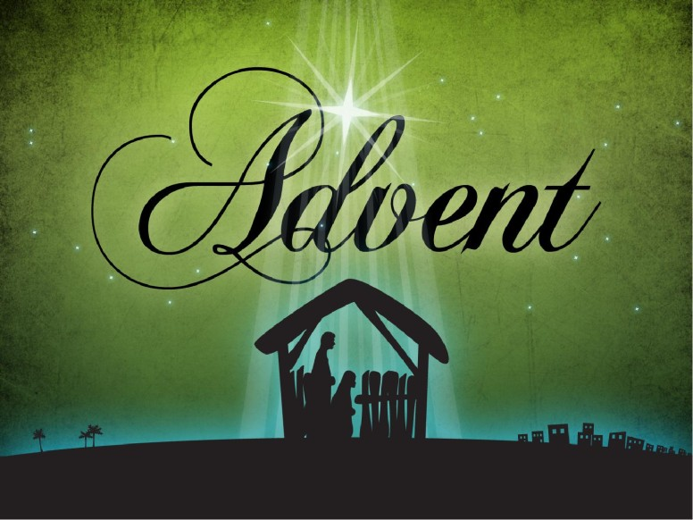

First United Methodist Church
30828 Irene Avenue P.O. Box 688
Lindstrom, Minnesota 55045
Phone: 651.257.4306
Email: firstmethodist@usfamily.net
www.lindstrommethodist.org

November 27, 2016
9:00 a.m.

